**В.Г. Беседина, И.А. Манухина**

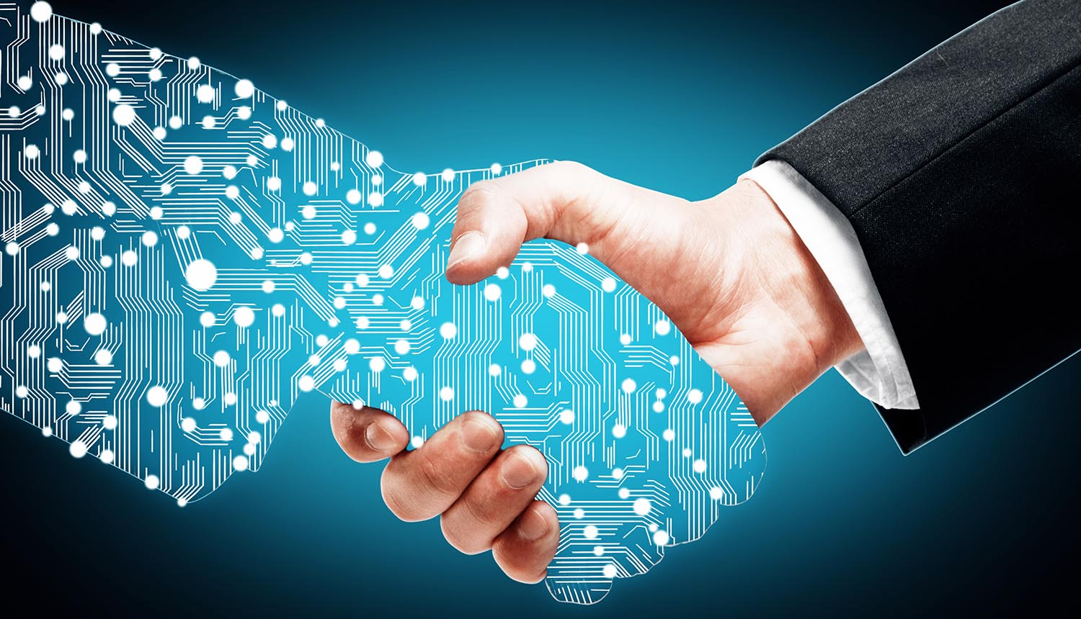

**PROFESSIONAL**

**IT ENGLISH**

Изд-во АлгГТУ

Барнаул 2019

Беседина В.Г. Professional IT English: учеб. пособие / В.Г. Беседина, И.А. Манухина; Алт. гос. тех. ун-т им. И.И.Ползунова. – Барнаул: Изд-во АлтГТУ, 2019. – 83 с.

Пособие предназначено для углубленного изучения английского языка в сфере информационных технологий.

Пособие состоит из 7 уроков, тематически охватывающих различные сферы использования современных информационных технологий. Каждый урок включает аутентичный профессионально-ориентированный текст, словарь с транскрипцией, упражнения для проверки понимания прочитанного, задания, способствующие усвоению специальных терминов, речевые упражнения, предполагающие ведение диалога, аргументированное высказывание своей точки зрения в ходе дискуссии, подготовку презентации по выбранной теме, различные виды ролевых игр.

СОДЕРЖАНИЕ

|  |  |
| --- | --- |
| **UNIT 1** BIG DATA……………………………………………………………. | 4 |
| **UNIT 2** DATA MINING……………………………………………………… | 14 |
| **UNIT 3** DATA SECURITY…………………………………………………… | 25 |
| **UNIT 4** CLOUD TECHNOLOGIES…………………………………………. | 35 |
| **UNIT 5** ARTIFICIAL INTELLIGENCE…………………………………….. | 47 |
| **UNIT 6** BIOMETRIC AUTHENTICATION………………………………… | 60 |
| **UNIT 7** HUMAN ENHANCEMENT………………………………………… | 71 |
| Список использованных источников……………………………………… | 80 |

UNIT 1

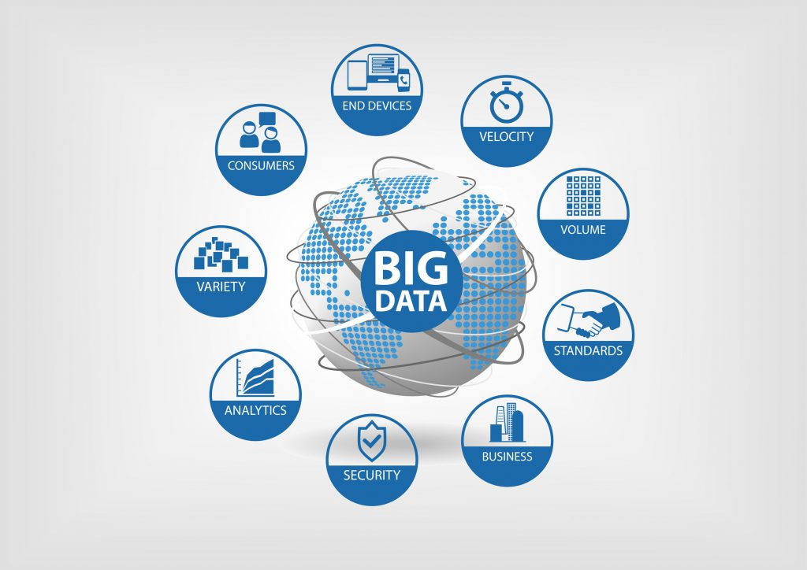

BIG DATA

|  |
| --- |
| **Preview**  **Answer the questions:**   1. How much data do you store on each of your devices? 2. How much data do you store online? 3. How has the volume of this data increased in the past few months? |

I. READING

Read and translate the text

**BIG DATA**

The term “big data” **refers** to an **accumulation** of data that is too large and **complex** for processing by traditional database management **tools**. It is possible to **gain** a better understanding of big data if it is described according to three vectors: **volume, velocity**, and **variety** – the three Vs.

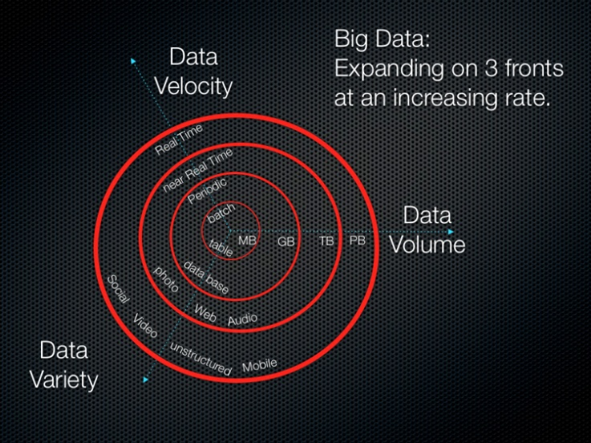**Volume** is the V most associated with big data because the quantities of big data can reach almost **incomprehensible** proportions. Facebook, for example, has more users than China has people. Since each of those users has uploaded a lot of photographs, Facebook is storing **roughly** 250 billion images.

**Velocity** is the vector representing the **measure** of how fast the data is coming in. Facebook, for example, has to handle a tsunami of photographs every day: its users upload more than 900 million photos a day. It has to **ingest** it all, process it, **file** it, and somehow, later, be able to **retrieve** it.

**Variety** is a vector that represents the growth of different data types and categories. Big data **incorporates** all the varieties of data. From excel tables and databases, data structure has changed to add hundreds of formats: pure text, photo, audio, video, web, GPS data, sensor data, relational data bases, documents, SMS, pdf, flash, etc. It's very different from application to application, and the **majority** of it is unstructured.

The **vast** amount of data, expanding in volume, velocity and variety in an increasing rate, was impossible to either capture or store in the past. It was simply too expensive or too **overwhelming**. Even if companies were able to capture the data, they didn’t have the tools to easily analyze the data and use the results to make decisions. Very few tools could **make sense of** these **vast** amounts of data. The tools that did exist were complex to use and did not produce results in a **reasonable** **time frame**.

In the end, those who really wanted to go to the enormous **effort** of analyzing this data **were forced to** work with **snapshots of data**. This had the **undesirable** effect of **missing** important **events** because they were not in a **particular** snapshot.

At present companies that know how to pragmatically use big data are able to **predict** the future, execute important business processes, or simply **gain** new **insights**.

*[Text is adapted from URL: http://www.dummies.com/programming/big-data/big-data-for-dummies-cheat-sheet/]*

II. NOTES

|  |  |
| --- | --- |
| accumulation [əˌkjuːmjəˈleɪʃn] | накопление, скопление |
| сomplex BrE [ˈkɒmpleks], AmE [kəmˈpleks] | сложный |
| associated [əˈsəʊʃieɪtɪd] [əˈsəʊsieɪtɪd] | связанный, ассоциируемый |
| tsunami [tsuːˈnɑːmi] | цунами |
| to file smth [faɪl] | регистрировать и хранить (документы) |
| type [taɪp] | тип |
| category [ˈkætəɡəri] | категория |
| excel [ɪkˈsel] table | таблица Excel |
| pdf [ˌpiː diː ˈef] | формат pdf (‘Portable Document Format’) |
| structure [ˈstrʌktʃə] | структура |
| enormous [ɪˈnɔːməs] | огромный |
| pragmatically [præɡˈmætɪkli] | прагматично, практично |

III. VOCABULARY

|  |  |
| --- | --- |
| 1. **big data** [ˈdeɪtə] | большие массивы данных |
| 1. **to refer to smth** [rɪˈfɜː] | относиться к чему-то, отсылать |
| 1. **tool** [tuːl]   database management tools | инструмент, средство  средства управления базами данных |
| 1. **to gain** [ɡeɪn]   to gain a better understanding of smth  to gain new insights | получить  лучше понять что-либо  понять что-то, осознать что-то новое на основе имеющейся информации |
| 1. **volume** [ˈvɒljuːm] | объём |
| 1. **velocity** [vəˈlɒsəti] | скорость |
| 1. **variety** [vəˈraɪəti] | разнообразие, многообразие |
| 1. **to incorporate** [ɪnˈkɔːpəreɪt]   Big data incorporates all the varieties of data. | включать в себя, вбирать в себя  Большие массивы данных включают в себя всё многообразие данных. |
| 1. **incomprehensible** [ɪnˌkɒmprɪˈhensəbl]   to reach incomprehensible proportions | непостижимый, недоступный пониманию  достигать невероятных размеров |
| 1. **roughly** [ˈrʌfli]   roughly 250 billion images | приблизительно, примерно  примерно 250 миллиардов изображений |
| 1. **measure** [ˈmeʒə]   to measure | мера, степень, масштаб  измерять |
| 1. **to ingest** [ɪnˈdʒest] | проглотить, принимать внутрь |
| 1. **to retrieve** [rɪˈtriːv] | извлечь, найти, восстановить |
| 1. **pure** [pjʊə]   **pure text** | чистый, без примесей  простой текст |
| 1. **majority** [məˈdʒɒrəti]   The majority of data is unstructured. | большинство, бльшая часть  Бльшую часть составляют неструк-турированные данные. |
| 1. **vast** [vɑːst]   vast amount | обширный, огромный, значительный  огромное количество |
| 1. **to expand** **in smth** [ɪkˈspænd] | расширяться, увеличиваться в чем-л. |
| 1. **overwhelming** [ˌəʊvəˈwelmɪŋ] | огромный, невыносимый, слишком трудоёмкий |
| 1. **to make sense of smth**   It doesn’t make sense. | осмыслить что-л., разобраться в чем-л.  Это непонятно. |
| 1. **reasonable** [ˈriːznəbl]   reasonable time frame | разумный, обоснованный, приемлемый  приемлемый срок, временные рамки |
| 1. **to be forced to do smth** | быть вынужденным делать что-то |
| 1. **snapshot** [ˈsnæpʃɒt]   snapshot of data | моментальный снимок  снимок данных, консолидированные за заданный период времени данные |
| 1. **undesirable** [ˌʌndɪˈzaɪərəbl]   undesirable effect | нежелательный  нежелательный эффект |
| 1. **to miss smth** | пропустить, упустить |
| 1. **event** [ɪˈvent] | событие |
| 1. **particular** [pəˈtɪkjələ] | отдельно взятый, определенный |
| 1. **effort** [ˈefət] | усилие |
| 1. **to predict** [prɪˈdɪkt]   Сompanies that know how to pragmatically use big data are able to predict the future. | предсказывать  Компании, умеющие извлекать практи-ческую пользу из больших массивов дан-ных, способны предсказывать будущее. |

IV. COMPREHENSION CHECK

**Answer the questions based on the text. More than one variant can be correct.**

1. **What was true about processing big data in the past?**
2. There were no tools to analyse big data.
3. It was difficult to receive the results very fast.
4. Analysing big data required little effort.
5. Many companies didn’t have enough money to analyse big data.
6. Some important events were missing in data analysis.
7. **What is NOT true about big data at present time?**
8. Big data is too large to process.
9. Big data incorporates all the varieties of data.
10. Some companies use big data to predict the future.
11. It’s possible to work only with snapshots of data.
12. The majority of big data is structured.
13. Big data analysis is never used to make business decisions.
14. **What is NOT directly stated in the text?**
15. Facebook has more users than China has people.
16. Big data incorporates sensor data.
17. It is cheap to analyse big data at present.
18. There are many tools to analyse big data at present.
19. Some companies know how to pragmatically use big data.
20. Instagram users upload millions of photos every day.

V. GRAMMAR

**ЭМФАТИЧЕСКИЕ КОНСТРУКЦИИ**

В различных ситуациях общения у говорящих может возникнуть необходимость в том, чтобы выразить эмоциональное отношение к какому-либо факту. Для этого используют специальные **эмфатические конструкции**, которые служат для выделе­ния того или иного члена предложения (от англ. **“emphatic”** – выразительный, подчеркнутый, выделенный).

Одним из способов привлечь внимание к действию, описываемому в предложении, служит эмфатическая конструкция **DO/DOES/DID + VERB**. Обратите внимание на то, что вспомогательный глагол используется в соответствующем времени, лице и числе. Смысловой глагол при этом используется в форме инфинитива без частицы to:

1. *I* ***do want*** *to come to the party.*

*Я действительно хочу прийти на вечеринку.*

1. *Susan* ***does like*** *to talk a lot!*

*Сьюзан в самом деле любит поговорить!*

1. *He* ***did come*** *yesterday.*

*Он всё же пришел вчера.*

Как правило, такая структура применяется, когда нужно подчеркнуть противоречие, возразить:

*Many companies nowadays* ***do capture*** *the data,* ***but*** *they don’t have the tools to easily analyze it.*

*В настоящее время многие компании фиксируют данные, но не обладают необходимыми инструментами для их эффективного анализа.*

*Facebook* ***does make it easy*** *for users to upload their photographs.* ***However****, the users should be able to retrieve the images easily as well.*

*Безусловно, Фейсбук позволяет пользователям без труда загружать свои фото на сайт. Однако необходимо, чтобы пользователи настолько же легко могли находить и извлекать нужные им фотографии.*

При переводе таких предложений для усиления значения перед сказуемым добавляются слова **действительно, несомненно, безусловно, на самом деле, всё же:**

*The tools that* ***did exist*** *were complex to use and did not produce results in a reasonable time frame.*

*Средства, которые* ***всё же существовали****, были сложны в использовании и не позволяли получить результат в приемлемые сроки.*

**VI. EXERCISES**

**Exercise 1. Change the sentences by adding emphasis to the verb. Then translate the sentences with emphatic construction into Russian.**

1. This had the undesirable effect of missing important events.
2. At present companies know how to pragmatically use big data.
3. Knowing how to pragmatically use big data helps to gain new insights.
4. Facebook handles a tsunami of photographs every day.
5. Facebook users upload more than 900 million photos a day.
6. Facebook stored roughly 250 billion images last year.
7. Some companies went to the enormous effort of analyzing data using the traditional tools.
8. Companies analyzed data in the past, but they were forced to work with snapshots of data.
9. The modern tools for data analysis produce results in a reasonable time frame.

**Exercise 2. Use emphatic constructions in answers to the following questions about smartphones.**

*Example A:* – ***Do you use*** *headphones to listen to the music? –* ***I do use*** *headphones to listen to the music,* ***but*** *when I’m at home alone I prefer to use speakers.*

*Example B: –* ***Do you use*** *headphones to listen to the music? – I do not use headphones to listen to the music now, because they are broken,* ***but******I do want*** *to buy new ones because* ***I do need*** *them!*

1. Do you have a vast amount of applications on your phone? – I ***do have*** a vast amount of applications, ***but*** …
2. Did you make sense of all the functions/features that your phone has?
3. Does your friend sometimes take snapshots of you?
4. Does your phone measure your internet traffic automatically?
5. Do most of your friends have Andriod operational system on their phones?
6. Did you think of buying a new phone for yourself?
7. Do you think your phone is a useful tool for your studies?
8. Does it take you a lot of effort to find and retrieve necessary information on your phone?
9. Do you know roughly the volume of free memory space on your phone?

**Exercise 3. Match each vocabulary word or phrase with its definition. Notice that there are more definitions than words.**

|  |  |
| --- | --- |
| _____pure | **1:** logical |
| _____tool | **2:** grow, become bigger |
| _____insights | **3:** speed |
| _____roughly | **4:** means of doing something |
| _____expand | **5:** something happening |
| _____predict | **6:** very difficult to fully understand |
| _____reasonable | **7:** variety |
| _____vast | **8:** small amount of |
| _____ingest | **9:** not exactly |
| _____incomprehensible | **10:** totally with nothing else mixed in |
| _____the majority of | **11:** understandings of deep things |
| _____event | **12:** huge |
| _____velocity | **13:** most |
| _____miss | **14:** describe a possible future event |
|  | **15:** not notice |
|  | **16**. eat |
|  | **17**. explain |

**Exercise 4. For each vocabulary word or phrase, circle TWO correct definitions.**

1. **roughly**:  
   **a)** very little  
   **b)** logically  
   **c)** approximately  
   **d)** small amount of  
   **e)** not exactly
2. **velocity**:
3. probability
4. a little bit of
5. speed
6. rare situation
7. rate
8. **incorporate**:
9. improve
10. break apart into tiny pieces
11. add
12. exclude
13. integrate
14. **gain new** **insights**:
15. get understanding of deep things
16. think carefully about
17. obtain ideas
18. travel abroad
19. meet new people
20. **incomprehensible**:
21. self-destructive
22. very confusing
23. understandable
24. clear
25. difficult to mentally process
26. **predict**:
27. try new things
28. describe a possible future event
29. to tell something to an enemy
30. forecast
31. test ideas scientifically
    * + 1. **retrieve**
32. reject
33. get back
34. eat
35. spend
36. recover
37. **ingest**:
38. loud and terrible
39. spoil
40. eat
41. consume
42. incorrect statement
43. **vast**:
44. men’s clothing
45. huge
46. to spread
47. computer virus
48. enormous
49. **pure**:
50. fresh
51. not polluted
52. food for babies
53. clean
54. tough

**12**. **majority**:

1. most
2. smaller part of
3. argument
4. military officer
5. mainstream

**13. measure**

1. fail to notice
2. degree of something
3. free time
4. amount of something
5. record by a camera

**Exercise 5. Put the given fragments in the right order to form questions.**

1. is / many / images / Facebook / how / storing / ? ………………………………
2. the velocity / represent / what / vector / does / ? …………………………………
3. have / does / what / handle / Facebook / every / day / to / ? ………………………………………………………………………………………
4. data formats / does / what / incorporate / big data / ? …………………………
5. impossible / why / it / to capture / in the past / data / was / vast / of / amount / ? ………………………………………………………………………………………
6. are / of / used / what / the results / data analysis / for / ? ………………………………………………………………………………………
7. what / with / was / the tools / existed / that / the problem / for analysing data / in the past / ? …………………………………………………………………………
8. be able / if / know / you / how to / data / what / pragmatically use / to do / will /?

………………………………………………………………………………………

**Exercise 6. Work in pairs. Ask each other questions found in Exercise 5.**

**Exercise 7. Fill in the blanks with appropriate words as you watch the video “What is Big Data and how does it work” (https://www.youtube.com/watch?v =TzxmjbL-i4Y). Note the meaning of the following words:**

to go way beyond [bɪˈjɒnd] – выходить далеко за рамки чего-л.

ridiculous [rɪˈdɪkjʊləs] – нелепый

treatment [ˈtriːtmənt] – лечение

to cure [kjʊə] – лечить, избавлять от чего-л.

cancer [ˈkænsə] – рак

So, we constanly produce a lot of _______. For example, via social media, public transport and _________. But it goes way beyond that: daily we upload _________________ pictures, __________________ tweets, and ____________________ documents. In total, we produce 2.5 quintillion _________ a day – that’s a lot of zeros, it’s ridiculous! We call this “big data”. But what’s actually more important is what you can _______ _______ it. To process big data, you don’t need ________ computers. People work with the __________ and endless ___________ of normal servers and powerful algorithms. This way, they can analyse over a ______________ pieces of data in minutes. And the result? Well, for example, video streaming website Netflix analysed the big data of their viewers, like __________ ________ and watching patterns. This way, they produced a ____________ series with the perfect combination of actors, directors, and story line. Right now the big data of __________ is being analysed to develop a car that can drive completely ___________________ all by itself! And in the future we can even use the big data of DNA to determine the ___________ treatment. This way, curing genetic diseases like cancer would become __________ ___________. And that’s just the ___________.

**According to the video, what spheres of life can be impoved by using big data analysis?**

**What specific examples of big data application are given?**

**What other new facts about big data have you learned from the video?**

VII. SPEAKING

**Exercise 1. Speak about velocity, variety and volume of data in your life.**

1. Do you upload photographs or documents to social networks or cloud storage?
2. How many files are you storing online?
3. Can you easily find the image or document you need? How much time does it usually take you to find it? What are some tools which help to retrieve a particular image or document from a file storage?
4. Do you think all your text messages are stored somewhere other than on your phone? Can anyone access them?
5. Is it possible to store everyone’s text messages?
6. In what spheres are sensors used? What are the functions of some of the sensors that you’ve seen? Where is the information from such sensors stored?

UNIT 2

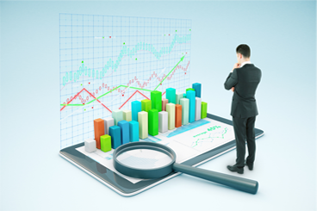

DATA MINING

|  |
| --- |
| **Preview**  **Answer the questions:**   1. How can big data be a problem? 2. How can it be an opportunity? 3. What is needed to make the maximum use of big data? |

I. READING

Read and translate the text

**DATA MINING: WHAT IT IS AND WHY IT MATTERS**

Data mining is the process of finding anomalies, **patterns** and **correlations** within large data sets to predict **outcomes**. Data mining is a **cornerstone** of analytics, helping you develop the models that can uncover connections within millions or billions of records. Using a **broad range of techniques**, you can use this information to **increase** **revenues**, **cut costs**, improve customer relationships, **reduce** **risks** and more.

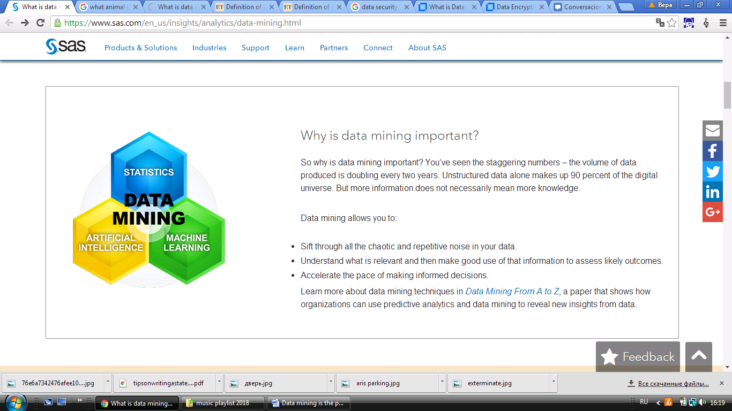The process of digging through data to discover hidden connections and predict future trends has a long history. However, the term "data mining" wasn’t **coined** until the 1990s. Its foundation comprises three **intertwined** scientific disciplines: statistics (the numeric study of data relationships), **artificial** **intelligence** (human-like intelligence displayed by software and/or machines) and machine learning (algorithms that can learn from data to make predictions).

Over the last **decade**, **advances** in processing power and speed have enabled us to move **beyond** **manual**, **tedious** and time-consuming practices to quick, easy and automated data analysis. The more complex the data sets collected, the more potential there is to uncover relevant insights. Retailers, banks, manufacturers, telecommunications providers and insurers, among others, are using data mining to discover relationships among everything from pricing, **promotions** and demographics to how the economy, risk, competition and social media are **affecting** their business models, revenues, operations and customer relationships.

Why is data mining important? While the volume of data produced is **doubling** every two years, more information does not necessarily mean more knowledge. Data mining allows you to:

* **sift** **through** all the chaotic and **repetitive** noise in your data;
* understand what is relevant and then make good use of that information to **assess** likely **outcomes**;
* **accelerate** the **pace** of making informed decisions.

Data mining, as a composite discipline, represents a variety of methods used to address different types of needs.

Descriptive modeling uncovers shared similarities or groupings in historical data to **determine** reasons behind success or failure, such as categorizing customers by product preferences or sentiment.

Predictive modeling goes deeper to classify events in the future or **estimate** unknown outcomes – for example, using **credit** **scoring** to determine an individual's **likelihood** of **repaying a** **loan**.

Prescriptive modeling looks at internal and external variables and **constraints** to recommend one or more **courses of action** – for example, determining the best marketing offer to send to each customer.

*[Text is adapted from: https://www.sas.com/en_us/insights/analytics/data-mining.html]*

II. NOTES

|  |  |
| --- | --- |
| correlation [ˌkɒrəˈleɪʃn] | Взаимоотношение |
| cornerstone [ˈkɔːnəstəʊn] | основа, краеугольный камень |
| trend [trend] | Тенденция |
| manual [ˈmænjuəl] | Ручной |
| decade[ˈdekeɪd] | Десятилетие |
| retailer [ˈriːteɪlə] | предприятие розничной торговли |
| manufacturer [ˌmænjuˈfæktʃərə] | Производитель |
| insurer [ɪnˈʃʊərə] | страховая компания, страховщик |
| descriptive modeling | описательное моделирование |
| predictive modeling | предиктивное моделирование |
| prescriptive modeling | прескриптивное моделирование |
| similarity [ˌsɪməˈlærəti] | Сходство |
| preferences [ˈprefərənsəz] | Предпочтения |
| sentiment [ˈsentɪmənt] | мнение, отношение |
| variables [ˈveriəbəlz] | Переменные |

III. VOCABULARY

|  |  |
| --- | --- |
| 1. **patterns** [ˈpætnz] | шаблоны, модели, принципы |
| 1. **outcomes** [ˈaʊtkʌmz] | перспективы, долгосрочные результаты |
| 1. **range** [reɪndʒ]   broad range of techniques[tekˈniːks] | диапазон, спектр  широкий спектр приемов |
| 1. **to increase** **revenues** [ɪnˈkriːs ˈrevənjuːz] | увеличить доходы |
| 1. **to cut costs** [kɒsts] | снизить затраты |
| 1. **to reduce** [rɪˈdjuːs] **risks**   You can use this information to increase revenues, cut costs, reduce risks and more. | снизить риски  Можно использовать эту информацию, чтобы увеличить доходы, снизить затраты, уменьшить риски и т.д. |
| 1. **to coin** [kɔɪn]   The term "data mining" wasn’t coined until the 1990s. | вводить в обращение, в употребление  Термин «data mining», обозначающий интеллектуальный анализ данных, был введен в обращение только в 90-е гг. |
| 1. **to intertwine** [ˌɪntəˈtwaɪn]   intertwined disciplines | переплетаться  связанные отрасли знания |
| 1. **artificial** **intelligence** [ˌɑːtɪˈfɪʃl ɪnˈtelɪdʒəns], **AI**  [eɪ ˈaɪ] | искусственный разум |
| 1. **advances** [ədˈvɑːns] **in smth**   Advancesin processing power and speed have enabled us to move to automated data analysis. | прогресс в чем-л, достижения  Увеличение мощностей и скорости обработки данных позволило перейти к их автоматизированному анализу. |
| 1. **beyond** [bɪˈjɒnd]   to move beyond smth to smth | вне, за рамками  перейти от чего-л. к чему-л. |
| 1. **tedious** [ˈtiːdiəs] | утомительный, трудоемкий |
| 1. **promotion** [prəˈməʊʃn] | рекламная кампания |
| 1. **to affect smth** [əˈfekt] | влиять на что-л. |
| 1. **to double** [ˈdʌbl]   The volume of data produced is doubling every two years. | удваиваться  Объем производимых данных удваивается каждые два года. |
| 1. **sift** **through smth** [sɪft θruː] | отфильтровать что-л. |
| 1. **repetitive** [rɪˈpetətɪv] | Повторяющийся |
| 1. **likely** [ˈlaɪkli]   to assess [əˈses] likely outcomes  **likelihood** [ˈlaɪklihʊd] | вероятный  оценивать наиболее вероятные результаты  вероятность |
| 1. **pace** [peɪs]   to accelerate the pace of smth | темп  ускорить темп чего-л. |
| 1. **to determine** [dɪˈtɜːmɪn] | определять |
| 1. **score** [skɔː]   credit scoring | сумма баллов  рейтинг кредитоспособности |
| 1. **to estimate** [estɪmət]   to estimate unknown outcomes | оценивать  оценивать возможный результат |
| 1. **loan** [ləʊn]   to repay a loan  Predictive modeling uses credit scoring to determine an individual's likelihood of repayinga loan. | кредит  выплатить кредит  Предиктивное моделирование ис-пользует рейтинг кредитоспособности при определении вероятности выплаты кредита заемщиком. |
| 1. **constraint** [kənˈstreɪnt] | Ограничение |
| 1. **course of action** [**ˌ**kɔːs əv ˈækʃn]   to recommend a course of action  Prescriptive Modeling looks at internal and external variables and constraints to recommend one or more courses of action. | план действий  рекомендовать план действий  Прескриптивное моделирование рассматривает внутренние и внешние переменные и ограничения, чтобы рекомендовать один или несколько планов действий. |

IV. COMPREHENSION CHECK

**Exercise 1. Choose the correct answer(s) to the following questions:**

1. **According to the text, what is data mining useful for?**
2. to predict outcomes;
3. to reduce revenues;
4. to develop customer relationships;
5. to increase costs.
6. **What is true about the term “data mining”?**
7. It was widely used until the 1990s.
8. It was not used after the 1990s.
9. It appeared on coins in the 1990s.
10. It started to be used in the 1990s.
11. **What is true about descriptive modelling?**
12. It’s one of the methods of data mining.
13. It is focused on the future outcomes.
14. It can identify groups of customers who bought the same product.
15. It is used to recommend one or more courses of action.
16. **Why is data mining important?**
17. It allows you to make uninformed decisions.
18. It doubles the information every two years.
19. It helps to understand what information is not relevant.
20. It helps make decisions faster.
21. **What spheres is data mining used in?**
22. Banking and insurance;
23. Retail and marketing;
24. Social media;
25. All of the above.
26. **What data mining method is used to suggest the best way to act in the future?**
27. Descriptive modeling;
28. Predictive modeling;
29. Provocative modelling;
30. Prescriptive modeling.

V. GRAMMAR

**ДВОЙНОЕ ОТРИЦАНИЕ КАК ЭМФАТИЧЕСКАЯ КОНСТРУКЦИЯ**

В английском языке двойное отрицание употребляется только в эмфатических целях. Два отрицания при этом нейтрализуют друг друга и создают оппозицию – утвердительное значение. Одно отрицание в таких случаях выражается грамматическим путем, а второе – при помощи приставок или слов, имеющих отрицательное значение.

*The term "data mining"* ***wasn’t*** *coined* ***until*** *the 1990s*.

*Термин «data mining», обозначающий интеллектуальный анализ данных,* ***был введен в обращение******только*** *в 90-е гг.*

*It is* ***not until******the business owners******see*** *some actual data mining models for their business that they start to understand the potential outcomes of the project.*

***Только после того,******как владельцы компаний увидят*** *реальные модели интеллектуального анализа данных для своего бизнеса, они начнут понимать возможные перспективы проекта.*

Отрицание **not**, употребляемое перед прилагательным или наречием с отрицательными приставками **un-, in- (il-, im-, ir-) dis-**, имеет усилительное значение, и все сочетание обычно соответствует русскому*"вполне, весьма, довольно + прилагательное (наречие)";* например:   
***not uncommon***− довольно обычный,   
***not infrequently***− довольно часто,   
***not impossible*** − весьма возможно.

**VI. EXERCISES**

**Exercise 1. Translate the sentences with emphatic construction into Russian.**

1. It is not impossible to sift through all the repetitive noise in your data.
2. It is not uncommon to use data mining to uncover shared similarities in historical data to determine reasons behind success or failure.
3. It was not until the analytics looked at internal and external variables and constraints that they could recommend two possible coursesofaction.
4. It is not infrequent that important hidden connections are discovered through data mining.
5. It's not unusual anymore for organizations to store multiple petabytes of data.
6. It is not unusual for organizations applying data mining techniques to see a 10-20 % revenue growth.
7. Demanding access to real-time data is not unreasonable and must be a priority for all organisations.
8. It was not until the early 2000 that two leading companies in the technology world – Yahoo! And Google – predicted the problems of storing and managing huge data and initiated work on finding a solution.

**Exercise 2. Make up questions based on the text.**

1. What _______________________________________________?
2. What kind of _________________________________________?
3. When _______________________________________________?
4. Who ________________________________________________?
5. Why ________________________________________________?
6. Where _______________________________________________?
7. How ________________________________________________?
8. How long ____________________________________________?
9. How many ___________________________________________?
10. How important________________________________________?

**Excercise 3. Work with a partner. Ask each other questions from exercise 2 and answer them.**

**Excercise 4. Insert words from the box into the following sentences.**

1. Using automated data analysis can reduce **t**____________ and complex manual calculations and improve the accuracy of the results.
2. Data mining can help produce personalized advertising and geographically targeted **p**____________s.
3. Many tools are designed to make it as easy as possible for you to **s**______ **t**________ the Social Data to find what is useful.
4. Data mining helps marketers **m**______ **b**_________ general stereotypes and zoom in on the specific customer.
5. Marketing departments can use big data to help their organizations **i**___________ **r**_______________ .
6. With the growing use of information technology and the recent **a**_____________ in web systems, the amount of data available to users has increased exponentially.
7. The application of big data analytics in healthcare has a lot of positive and also life-saving o______________.
8. The vast majority of the volume of data found in Big Data is typically **r**____________ data.
9. Internet of Things and big data are closely **i**_______________ and although they are not the same thing, it is very hard to talk about one without the other.
10. Uninstalling an important application can **a**_________ your computer’s operation.

**Excercise 5. Translate the following sentences.**

1. Корпорации могут иметь доступ к огромному объему своих данных и не иметь необходимых инструментов, чтобы использовать эти данные для увеличения доходов.
2. Современные технологии позволяют компаниям ускорить темп принятия решений.
3. Специальные алгоритмы позволяют обнаружить повторяющиеся шаблоны в больших массивах данных.
4. Чтобы получить наилучший результат, специалист должен знать широкий спектр приемов в области анализа больших массивов данных.
5. Достижения в современных технологиях позволили минимизировать утомительный ручной труд.
6. Вероятность положительного результата увеличилась вдвое.
7. Из-за недостатка информации было трудно определить наилучший план действий.
8. Рейтинг кредитоспособности используется банками, чтобы снизить риски невыплаты кредита.
9. Большое количество ограничений негативно повлияло на успех рекламной компании.
10. Искусственный разум позволяет выйти за рамки обычных человеческих возможностей.

VI. SUPPLEMENTARY READING

1. **Answer the following pre-reading questions:**

* **What songs or poems do you know which were probably written by people suffering from depression? How can you tell the author was depressed based on the language of his writing? Is it always easy to see?**
* **How can data mining technologies be used to detect depression?**

1. **While reading, pay attention to the pronunciation of the following words:**

suffer [ˈsʌfə] – страдать

suicide[ˈsjuːɪsʌɪd]– самоубийство

**singular pronoun** [ˈsɪŋɡjʊlə ˈprəʊnaʊn]– местоимение единственного числа

**spinal cord injury** [ˈspaɪnəl kɔːd ˈɪndʒəri] – травма позвоночника

recreation [ˌrekriˈeɪʃən] – отдых, развлечение

**PEOPLE WITH DEPRESSION USE LANGUAGE DIFFERENTLY – HERE’S HOW TO SPOT IT**

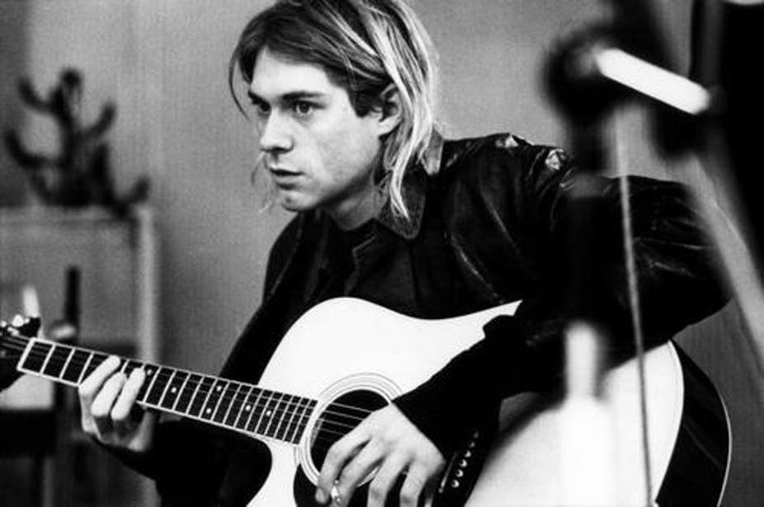Depression changes the way you move and sleep, and is even noticeable in the way you express yourself in writing. Sometimes this “language of depression” can have a powerful effect on others. Just consider the impact of the poetry and song lyrics of Sylvia Plath and Kurt Cobain, who both killed themselves after suffering from depression.

Scientists have long tried to pin down the exact relationship between depression and language, and technology is helping us get closer to a full picture. Traditionally, linguistic analysis have been carried out by researchers reading and taking notes. Nowadays, computerised text analysis methods allow the processing of extremely large data banks in minutes. This can help spot linguistic features which humans may miss.

A new study has now unveiled a class of words that can help accurately predict whether someone is suffering from depression. Computerized text analysis of [personal essays](http://www.tandfonline.com/doi/abs/10.1080/02699930441000030) and [diary entries](http://onlinelibrary.wiley.com/doi/10.1111/j.1467-6494.2010.00627.x/full) by depressed people as well as the work of well-known artists such as [Cobain](https://cloudfront.escholarship.org/dist/prd/content/qt0dh4553j/qt0dh4553j.pdf) and [Plath](https://journals.lww.com/psychosomaticmedicine/Abstract/2001/07000/Word_Use_in_the_Poetry_of_Suicidal_and_Nonsuicidal.1.aspx) revealed clear and consistent differences in language between those with and without symptoms of depression.

It will surprise no one to learn that those with symptoms of depression use a great amount of words conveying [negative emotions](http://journals.sagepub.com/doi/abs/10.1177/0261927X09351676), such as “lonely”, “sad” or “miserable”. More interesting is the use of pronouns. Those with symptoms of depression use [significantly more first person singular pronouns](http://www.tandfonline.com/doi/abs/10.1080/02699930441000030) – such as “me”, “myself” and “I” – and [significantly fewer](https://www.ncbi.nlm.nih.gov/pubmed/6176285) second and third person pronouns – such as “they”, “them” or “she”. This pattern suggests people with depression are more focused on themselves, and less connected with others.

A big data text analysis of 64 different online mental health forums, examining over 6,400 members, found that “absolutist words”, such as “always”, “nothing” or “completely” can be even better markers of depression, reflecting a more black and white view of the world people with depression have.

Researchers are combining automated text analysis with [machine learning](https://theconversation.com/deepmind-can-we-ever-trust-a-machine-to-diagnose-cancer-88707) (computers that can learn from experience without being programmed) to [classify a variety of mental health conditions](https://ieeexplore.ieee.org/abstract/document/6784326/) from natural language text samples such as blog posts. Such classification is already outperforming that made by trained therapists. Importantly, machine learning classification will only improve as more data is provided and more sophisticated algorithms are developed.

As the World Health Organisation estimates that more than 300m people worldwide are now living with depression, an increase of more than 18% since 2005, having more tools available to spot the condition is certainly important to improve health and prevent tragic suicides such as those of Plath and Cobain.

*[The text is adopted from URL: theconversation.com/people-with-depression-use-language-differently-heres-how-to-spot-it-90877]*

1. **After reading the text, choose synonym to the words in italics:**
2. People with depression use language differently – here’s how to *spot* it.
3. to notice
4. to buy
5. to hide
6. to speak
7. Scientists have long tried *to pin down* the exact relationship between depression and language.
8. to advertise
9. to discuss
10. to forget
11. to understand
12. A new study has now *unveiled* a class of words that can help accurately predict whether someone is suffering from depression.
13. improved
14. guessed
15. discovered
16. disagreed with
17. Those with symptoms of depression use a great amount of words *conveying* [negative emotions](http://journals.sagepub.com/doi/abs/10.1177/0261927X09351676), such as “lonely”, “sad” or “miserable”.
18. communicating
19. hiding
20. preventing
21. improving
22. Such classification is already *outperforming* that made by trained therapists.
23. shown to the public
24. changing
25. better
26. improving
27. **What other text analysis applications can you think of?**

II. SPEAKING

**Exercise 1. Prepare a report (presenation) on one of the following topics:**

1. Data Mining in Sports
2. Data Mining in Medicine
3. Data Mining in Social Media
4. Data Mining in Agriculture
5. Data Mining in Fighting Crime
6. Data Mining in Banking
7. Data Mining in Retail
8. Data Mining in Food Industry
9. Data Mining in Traffic Control
10. Data Mining in Weather Forcasting
11. Data Mining in Space Exploration

**Exercise 2. Discuss ethical issues of data mining. Is it possible to misuse big data? Speak of beneficial and harmful ways to use the following types of data:**

* Current location data;
* History of previously visited locations;
* Facial recognition;
* Online consumer data;
* Friends lists on social media;
* E-mail address database;
* Medical records.

UNIT 3

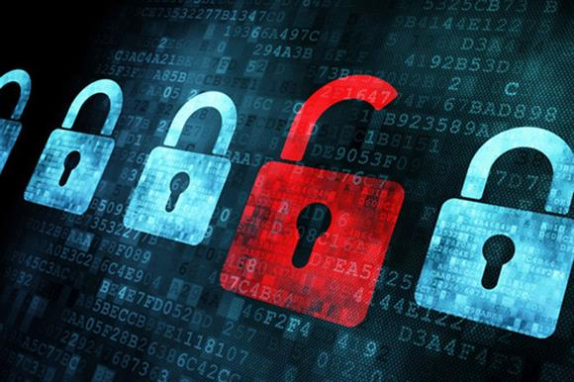

DATA SECURITY

|  |
| --- |
| **Preview**  **Answer the questions:**   1. Do you buy anything online? Do you feel safe making online payments? 2. Have you or anyone you know ever been a victim of a cybercrime or a hacker’s attack? 3. What rules does one have to follow to prevent losing data or money online? |

I. READING



Read and translate the text

**DATA SECURITY**

Data security refers to the process of protecting data from **unauthorized access** and data **corruption** **throughout** its lifecycle. Data security is also known as information security (IS) or computer security. It is an essential aspect of IT for organizations of every size and type. Security **measures** include data **encryption**, tokenization and key management practices.

Encryption is the process of using an algorithm to transform **plain** text information into a non-readable form called **ciphertext**. An algorithm and an encryption key are required to decrypt the information and return it to its original plain text format.

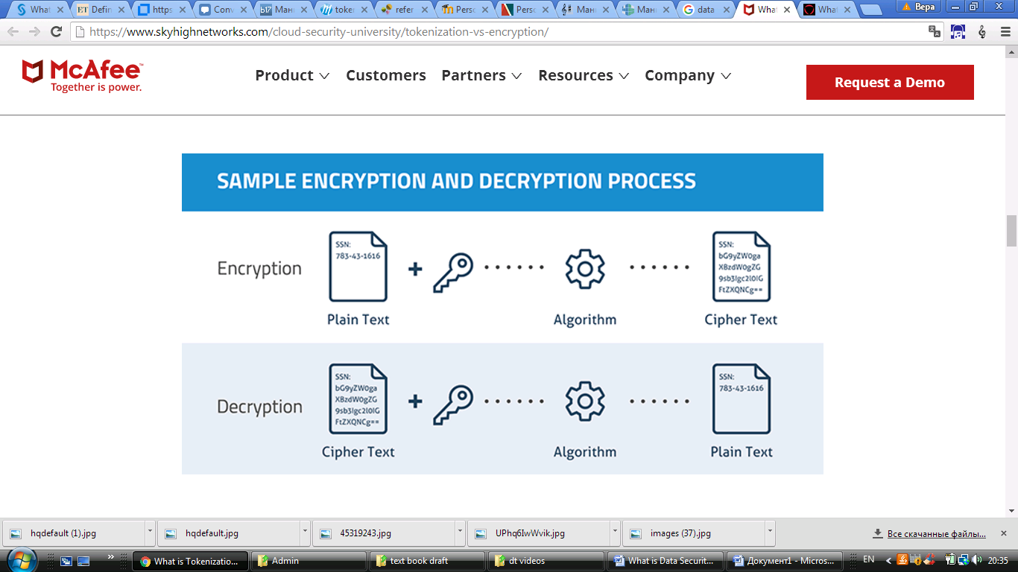

Figure 1. – Sample Encryption and Decryption Process

(Источник: https://www.skyhighnetworks.com/cloud-security-university/tokenization-vs-encryption/)

Tokenization is the process of turning a meaningful piece of data, such as an account number, into a random **string** of characters called a **token**. The **advantage** of tokens is that there is no mathematical relationship to the real data they represent. If they are **breached**, they have no meaning. There is no key, or algorithm, that can reverse them back to the real data **values**. Instead, tokenization uses a database, called a token **vault**, which stores the relationship between the sensitive value and the token.

The token value can be used in various applications as a substitute for the real data. For example, in the case of processing a credit card payment, the token is **submitted** to the vault to **retrieve** the real value – the **account** number – for use in the authorization process. Very often the end user is not even **aware** that the data is stored in the cloud in a different format.

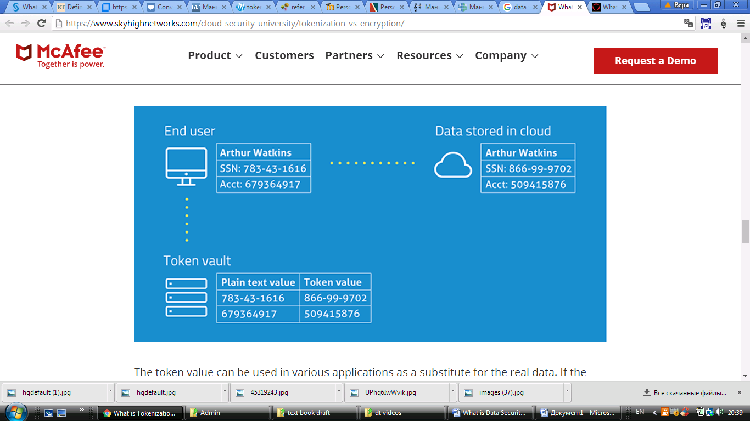

Figure 2. – Sample Tokenization Process

(Источник: https://www.skyhighnetworks.com/cloud-security-university/tokenization-vs-encryption/)

Besides encryption and tokenization, good key management practices are essential for protecting sensitive data, as its security crucially depends on the security of the cryptographic key that allows the data to be decrypted. As a result, the problem of protecting personal data **is** **reduced** **to** the problem of protecting such keys from unauthorized access and use. For example, keys must never be stored in the same place as encrypted data and only the **authenticated** users should get access to the encrypted resources.

Another important component of key management is **keeping track** of the events which have happened in the application. Each and every access to the set of data which is encrypted because of its high **degree** of sensitivity should be **logged** in detail, identifying the user who has accessed the sensitive data, the data which is being accessed, and the time when the data is accessed.

II. NOTES

|  |  |
| --- | --- |
| lifecycle [ˈlaɪf saɪkl] | жизненный цикл |
| original [əˈrɪdʒənl]  original format [ˈfɔːmat] | первоначальный  первоначальный формат |
| random [ˈrændəm] | случайный, произвольно выбранный |
| character [ˈkærəktə] | цифра, буква, знак, символ |
| to represent [ˌreprɪˈzent] | представлять |
| to reverse [rɪˈvɜːs] | возвращать, обращать |
| SSN – Social Security Number | номер свидетельства соц. страхования |
| sensitive [ˈsensətɪv]  sensitive value  sensitive data  sensitivity | засекреченный, секретный, уязвимый  засекреченное цифровое значение  секретные данные, конфиденциальная информация  конфиденциальность |
| substitute [ˈsʌbstɪtjuːt] | заменитель, замена |
| various [ˈveəriəs] | различный |
| component [kəmˈpəʊnənt] | часть, деталь, компонент |
| to identify [aɪˈdentɪfaɪ] | определить, установить личность |

III. VOCABULARY

|  |  |
| --- | --- |
| 1. **throughout** [θruːˈaʊt] | на всём протяжении |
| 1. **to authorize** [ˈɔːθəraɪz]   unauthorized access  authorization [ˌɔːθəraɪˈzeɪʃn] | давать разрешение  несанкционированный доступ  проверка регистрационной информации о пользователе |
| 1. **corruption** [kəˈrʌpʃn]   data corruption  Data security refers to the process of protecting data from unauthorized access and data corruption throughout its lifecycle. | повреждение, разрушение  нарушение целостности данных  Под обеспечением сохранности дан-ных понимается процесс защиты дан-ных от несанкционированного досту-па и от нарушения целостности на протяжении всего жизненного цикла. |
| 1. **measure** [ˈmeʒə]   security measures | мера  меры безопасности |
| 1. **encryption** [ɪnˈkrɪpʃn]   data encryption  to encrypt / to decrypt | шифрование  шифрование данных  зашифровать / расшифровать |
| 1. **plain** [pleɪn]   plain text | простой, понятный  обычный, незашифрованный текст |
| 1. **ciphertext** [ˈsaɪfətekst]   Encryption is the process transforming plain text information into a ciphertext. | зашифрованный текст  Шифрование – это процесс преобра-зования информации в форме простого текста в зашифрованный текст. |
| 1. **token** [ˈtəʊkən]   tokenization [ˈtəʊkənaɪˈzeɪʃn] | токен, жетон, ярлык, символ токенизация |
| 1. **string** [strɪŋ]   random string of characters | веревка, нить, струна, строка  строка случайных символов |
| 1. **vault** [vɔːlt]   A token vault stores the relationship between the sensitive value and the token. | хранилище  Хранилище токенов содержит соотношения засекреченных значений и их «ярлыков» – токенов. |
| 1. **advantage** [ədˈvɑːntɪdʒ]   disadvantage | преимущество  недостаток |
| 1. **to breach** [briːtʃ]   security breach  The advantage of tokens is that if they are breached, they have no meaning. | нарушить целостность, создать брешь  нарушение защиты  Преимущество токенов в том, что в случае утечки сами по себе они лишены смысла. |
| 1. **value** [ˈvæljuː]   data values | значение  значения данных |
| 1. **account** [əˈkaʊnt]   account number | счет  номер счета |
| 1. **to submit** [səbˈmɪt] | представлять на рассмотрение, предъявлять |
| 1. **to retrieve** [rɪˈtriːv]   The token is submitted to the vault to retrieve the real value for use in the authorization process. | извлекать  Токен предъявляется в хранилище для извлечения реального значения, которое затем используется в процессе авторизации. |
| 1. **to be aware** [əˈweə] **of smth**   The end user is not even aware that the data is stored in the cloud in a different format. | быть в курсе чего-л., отдавать себе отчет в чем-л.  Конечный пользователь может даже не отдавать себе отчет в том, что данные хранятся в облаке в другом формате. |
| 1. **to reduce** [rɪˈdjuːs] **smth to smth**   The problem of protecting personal data is reduced to the problem of protecting cryptographic keys from unauthorized access and use. | cводить что-л. к чему-л.  Проблема защиты персональных данных сводится к проблеме защиты ключей от несанкционированного доступа и использования. |
| 1. **authenticated** [ɔːˈθentɪkeɪt] **user**   Only the authenticated users should get access to the encrypted resources. | аутентифицированный пользователь  Только аутентифицированные пользователи должны получать доступ к зашифрованным ресурсам. |
| 1. **to keep track** [træk] **of smth**   Another important component of key management is keeping track of the events which have happened in the application. | отслеживать, фиксировать  Еще одной важной задачей при управлении ключами является отслеживание событий, произо-шедших в приложении. |
| 1. **degree** [dɪˈɡriː]   high degree of sensitivity | степень  высокая степень конфиденциальности |
| 1. **to log smb’s access to data in**   **detail**  Every access to the set of data which is encrypted because of its high degree of sensitivity should be logged in detail. | зарегистрировать все параметры ч-л доступа к данным  Следует регистрировать все параметры каждого случая получения доступа к данным, зашифрованным по причине высокой степени их конфиденциальности. |

IV. COMPREHENSION CHECK

**Exercise 1. Compare the encryption and tokenization processes by filling in the table:**

|  |  |  |
| --- | --- | --- |
|  | **Encryption** | **Tokenization** |
| What does this process transform the given data into? |  |  |
| What is required to return the information to its original form? |  |  |
| Where can this security measure be used? |  |  |
| What is the advantage of this method? |  |  |

**Exercise 2. Think of a title for each paragraph of the text and write down your ideas below:**

1. _______________________________________
2. _______________________________________
3. _______________________________________
4. _______________________________________
5. _______________________________________
6. _______________________________________

**V. EXERCISES**

**Exercise 1. Make up questions based on the text.**

1. What _______________________________________________?
2. What kind of _________________________________________?
3. When _______________________________________________?
4. Who ________________________________________________?
5. Why ________________________________________________?
6. Where _______________________________________________?
7. How ________________________________________________?
8. How long ____________________________________________?
9. How many ___________________________________________?
10. How important________________________________________?

**Excercise 2. Work with a partner. Ask each other questions from exercise 2 and answer them.**

**Exercise 3. Complete the definitions of the terms from the text by filling in the blanks. Note *the verbs* which are usually used to define something.**

1. __________________ **is** the process of using an algorithm to transform ciphertext back to its original plain text format.
2. A database which stores the relationship between the sensitive value and the token **is known as** a ______________________.
3. A value that is applied using an algorithm to a plain text to produce encrypted text **is known as** ____________________.
4. The practices of protecting cryptographic keys from unauthorized access and use **are called** ___________________________.
5. The process of turning a meaningful piece of data into a random string of characters **is called** _______________________.
6. A substitute for the real data which has no meaning is called a ___________.
7. ________________ **refers to** the process of using an algorithm to transform plain text information into a non-readable form.
8. ________________ **refers to** the process of protecting data from unauthorized access and data corruption throughout its lifecycle.

**Exercise 4. Learn to give the definitions from exercise 4 *quickly* without looking at the text.**

**Exercise 5. Fill in the blanks with vocabulary words in appropriate form.**

1. Real-time access to log data will allow you to filter and locate that one event that could be the cause of a **s**___________ **b**__________.
2. Company management is often not **a**______ of some security **m**_________.
3. On your website you can define the rule to allow only **a**______________ **u**_______ to access specific services.
4. In this company all data security measures are **r**____________ to changing passwords once a week.
5. Special software allows you to **l_______ a____________** to sensitive data.
6. Is there a log file I can set up to **k_**______ **t**______ of who accessed what files and what they did with them – i.e. deleted, changed and so on?
7. Financial-related personal data has higher **d**_________of  **s**_____________.
8. Improper shutdowns of a computer may cause **d**________ **c**____________.

**Exercise 6. Fill in the empty cells with appropriate word from the box.**

**ciphertext unauthorized advantage reduce**

**non-readable decrypt sensitive data**

|  |  |  |
| --- | --- | --- |
| **Synonym** | **Synonym** | **Antonym** |
| allowed | authorized |  |
| encode | encrypt |  |
| original text | plain text |  |
| benefit |  | disadvantage |
| personal data |  | data open to public |
|  | decrease | increase |
| clear | readable |  |

**Exercise 7. Translate the sentences into English.**

1. Как правило, для защиты конфиденциальных данных используется шифрование, но в последние несколько лет значительно возрос интерес к другой технологии – токенизации.
2. Шифрование имеет много преимуществ и является одним из наиболее эффективных средств обеспечения безопасности конфиденциальных данных.
3. Шифрование позволяет обеспечить доступ к данным только авторизованным пользователям и защищает данные как при хранении, так и при передаче.
4. Но шифрование – не единственная мера безопасности, есть и альтернативные методы.
5. Иногда самым правильным решением будет не защитить конфиденциальные данные шифрованием, а вообще не передавать их.
6. Токенизация является технологией, которая предоставляет эту возможность – ее принцип заключается в подмене реальных значений данных строкой случайных символов – токеном.
7. В случае шифрования процесс сокрытия данных обратим: любой человек, имеющий ключ шифрования, сможет преобразовать зашифрованный текст в первоначальный формат.
8. В случае с токенизацией процесс не является обратимым, так как токен, предъявляемый вместо данных, не несет в себе никакой конфиденциальной информации и не имеет алгоритма, который может восстановить реальные значения данных.
9. Соотношение «ярлыка» с реальными данными хранится в хорошо защищенной базе данных, называемой «хранилище токенов».
10. В случае утечки токен не поможет извлечь никакие реальные конфиденциальные данные.
11. Токенизация идеально подходит для защиты конфиденциальных данных, таких как номера счетов и номера социального страхования.

VII. SPEAKING

**Exercise 1. Prepare a report (a presentation) on one of the following topics:**

1. Keeping your cryptographic keys safe and secure (suggested resource: <https://www.cryptomathic.com/news-events/blog/cryptographic-key-management-the-risks-and-mitigations>)
2. Classification of cryptographic keys (suggested resource: <https://www.cryptomathic.com/news-events/blog/classification-of-cryptographic-keys-functions-and-properties>)
3. The full life-cycle of cryptographic keys (suggested resource: <https://info.townsendsecurity.com/definitive-guide-to-encryption-key-management-fundamentals#The-Full-Life-Cycle-of-Keys>)
4. Famous cases of data security breaches (suggested resource: <https://gizmodo.com/target-confirms-that-encrypted-pins-were-swiped-in-blac-1490418755>; https://www.computerweekly.com/news/2240237912/ Sony-Pictures-admits-it-was-unprepared-for-Novembers-cyber-attack)
5. Tokenization of personal credit card payments (suggested resource: <https://jointoken.com/#/>)
6. Tokenization of mobile payments (suggested resource: <https://www.retaildive.com/ex/mobilecommercedaily/biometrics-tokenization-gain-steam-with-mastercard-visa-commitments> )
7. Unbreakable encryption (suggested resource: http://fortune.com/2013/10/14/unbreakable-encryption-comes-to-the-u-s/ )

**Exercise 2. Prepare a list of questions to ask a data security specialist about different methods of data protection and problems of data security management. Act out an interview with one of your classmates playing the role of a data security expert.**

UNIT 4

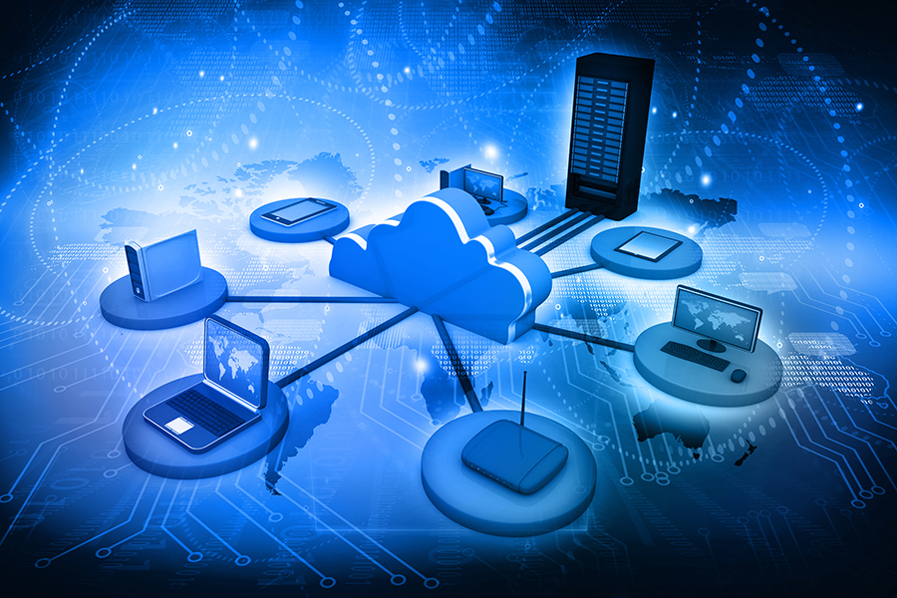

CLOUD TECHNOLOGY

|  |
| --- |
| **Preview**  **Answer the questions:**   1. How have cloud technologies changed the IT sphere? 2. What are the advantages and disadvantages of cloud computing? 3. What cloud providers are popular? |

I. READING

**Read and translate the text**

**CLOUD TECHNOLOGY**

**Cloud** technology services cover a vast range of options, from the basics of storage, networking, and processing power through to natural language processing and artificial intelligence as well as standard office applications. Companies offering these computing services are called cloud providers and typically **charge for** cloud computing services based on usage, similar to how you are **billed for** water or electricity at home.

Cloud computing services can be private, public and hybrid. [**Private cloud**](http://searchcloudcomputing.techtarget.com/definition/private-cloud)**services** are **delivered** from a business's data center to **internal users**. Internal users may or may not be billed for services through [IT chargeback](http://searchaws.techtarget.com/definition/IT-chargeback-showback). 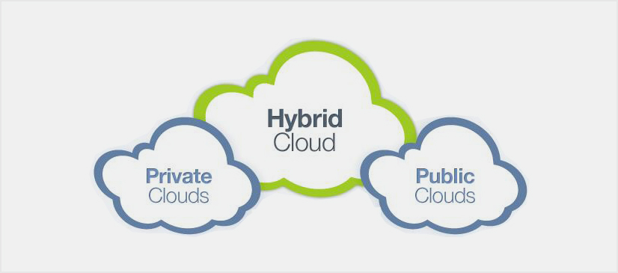In the [**public cloud**](http://searchcloudcomputing.techtarget.com/definition/public-cloud)**model**, a **third-party** cloud **service provider** delivers the cloud service over the Internet. Customers only pay for the [CPU](http://whatis.techtarget.com/definition/processor) cycles, [storage](http://searchstorage.techtarget.com/definition/storage) or [bandwidth](http://searchenterprisewan.techtarget.com/definition/bandwidth) they consume.

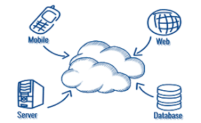A [**hybrid cloud**](http://searchcloudcomputing.techtarget.com/definition/hybrid-cloud) is a combination of public cloud services and an on-premises private cloud, with orchestration and automation between the two. The goal of a hybrid cloud is to create a unified, automated, scalable **environment** that **takes advantage of** all that a public cloud infrastructure can provide, while still **maintaining control** over mission-critical data.

Cloud technologies architecture refers to the various components and sub-components of cloud that constitute the structure of the system. This architecture can be classified into two sections: **front-end** and **back-end**. **Front End** is the visible interface that computer users or clients **encounter** through their **web-enabled client devices**. But it should be clear here that not all cloud technologies systems will use the same user interface. **Back End** is the **“cloud”** part of a cloud technologies architecture, **comprising** all the resources required to deliver cloud-technologies services. A system’s back end can be made up of a number of metal servers, data storage facilities, virtual machines, a security mechanism, and services, all built in **conformance** with a deployment model, and all together responsible for providing a service.

Security remains a **primary concern** for businesses thinking about cloud adoption – especially public cloud adoption. Public cloud service providers share their underlying hardware infrastructure between numerous customers, as public cloud is a multi-tenant environment. This environment demands isolation between logical compute resources. At the same time, access to public cloud storage and compute resources is guarded by account **login credentials**.

II. NOTES

|  |  |
| --- | --- |
| to constitute [ ˈkɒnstɪˌtjuːt ] | составлять |
| orchestration [ ˈɔːkɪˌstreɪʃn] | взаимодействие, механизм управления |
| automation [ ˌɔːtəˈmeɪʃn] | автоматизация |
| infrastructure [ ˈɪnfrəˌstrʌktʃə] | инфраструктура |
| unique [ juːˈniːk ] | уникальный |
| architecture [ ˈɑːkɪˌtektʃə ] | архитектура |
| structure [ ˈstrʌktʃə] | структура |
| to classify [ ˈklæsɪfaɪ] | классифицировать |
| section [ˈsekʃn] | секция, часть |
| hybrid [ˈhaɪbrɪd] | гибридный |
| public [ˈpʌblɪk] | общедоступный |
| unified [ˈjuːnɪfaɪd ] | унифицированный |
| mechanism [ˈmekəˌnɪzm] | механизм |
| numerous [ˈnjuːmərəs] | многочисленный |
| various [ˈveəriəs] | различный |
| mission [ˈmɪʃn] | миссия |

III. VOCABULARY

|  |  |
| --- | --- |
| **1. cloud** [klaʊd]  cloud technology / cloud adoption  cloud providers  public cloud  hybrid cloud  private cloud service  on-premises [ən ˈpremɪsɪz] private cloud | облако  облачные технологии  поставщики облачных услуг  облако общего доступа  гибридное облако  услуга по предоставлению частного облака  локальное облако, установленное на площадке заказчика |
| **2. to charge** [tʃɑːdʒ] **for smth**  to charge for cloud computing services | брать плату за ч.-л.  брать плату за услуги облачных вычислений |
| **3. to bill** [bɪl]  to be billed for smth  to be billed for water or electricity  to be billed for services through IT chargeback. | выставлять счёт  получать счет за что-л.  получать счет за воду и электричество  получать счет за услуги посредством электронных возвратных платежей |
| **4. environment** [ɪnˈvaɪrənmənt]  scalable environment  multi-tenant environment | среда  масштабируемая среда  многопользовательская среда |
| **5. to deliver** [dɪˈlɪvə]  to deliver services over the Internet | поставлять  предоставлять услуги через Интернет |
| **6. a third-party service provider** [ə θɜːd ˈpɑːtɪ sɜːvɪs prəˈvaɪdə] | предоставляющая услуги третья сторона; сторонний поставщик |
| **7. to take advantage** **of smth**  to take advantage of all that a public cloud infrastructure can provide | воспользоваться ч.-л.  воспользоваться всем тем, что может общедоступное облако предоставить |
| **8. to maintain control over smth**  [meɪnˈteɪn]  to maintain control over mission -critical data | поддерживать контроль над ч-л.  поддерживать контроль над особо важными данными |
| **9. front-end** [ˈfrʌnt end] | внешний, клиентский |
| **10. back-end** [ˈbæk end] | внутренний, серверная часть |
| **11. to encounter** [ɪnˈkaʊntə]  to encounter through web-enabled client devices | сталкиваться  сталкиваться, используя устройства пользователя, реализованные на основе веб-приложений |
| **12. to comprise** [kəmˈpraɪz]  to comprise all the resources required to deliver cloud-technologies services | включать, охватывать  включать все ресурсы, необходимые для предоставления услуг облачных технологий |
| **13. in conformance** [kənˈfɔːməns] **with**  to be built in conformance with a deployment model | в соответствии с  быть построенным в соответствии с моделью развертывания |
| **14. to remain a primary concern for**  **smb** [ˈpraɪmərɪ kənˈsɜːn]  Security remains a primary concern for businesses. | иметь особую важность  Безопасность имеет особую важность для предприятий. |
| **15. login credentials** [krɪˈdenʃəlz]  Access to public cloud storage and compute resources is guarded by account login credentials. | учётные данные  Доступ к общедоступным облачным хранилищам и вычислительным ресурсам охраняется учетными данными входа в учетную запись. |

IV. READING COMPREHENSION

**Exercise 1. Think of a title for each paragraph of the text and write down your ideas below:**

1. …………………………………………………………………………
2. …………………………………………………………………………
3. …………………………………………………………………………
4. …………………………………………………………………………
5. …………………………………………………………………………

**Exercise 2. Answer the questions.**

**1. What is NOT true about сloud technology services?**

1. Cloud computing services can be private, public and hybrid.
2. Cloud technology services cover only standard office applications.
3. Cloud providers normally charge forcloud computing services based on usage.

**2. What is NOT true about the types of сloud services?**

1. The customers of [public cloud](http://searchcloudcomputing.techtarget.com/definition/public-cloud) servicespay for the [CPU](http://whatis.techtarget.com/definition/processor) cycles through [IT chargeback](http://searchaws.techtarget.com/definition/IT-chargeback-showback).
2. [Private cloud](http://searchcloudcomputing.techtarget.com/definition/private-cloud) services are delivered from a company's data center to both internal and external users.
3. A [hybrid cloud](http://searchcloudcomputing.techtarget.com/definition/hybrid-cloud) serviceis a combination of public cloud services and an on-premises private cloud.

**3. What is NOT true about cloud technologies architecture?**

1. **Back End** is the **“visual”** part of a cloud technologies architecture.
2. Cloud technologies architecture includes various components and sub-components of the cloud.
3. Cloud technologies architecture can be classified into two sections: front-end and back-end.

**4. What is NOT true about public cloud** **security?**

1. Public cloud is a multi-tenant environment, so the underlying hardware infrastructure is shared between numerous customers.
2. Unfortunately, access to public cloud storage and compute resources can not be guarded by account login credentials.
3. Security still remains a primary concernfor businesses thinking about public cloud adoption.

**Exercise 3. Make up questions based on the text.**

1. What …………………………………………………………………………?
2. What kind of ……………….………………………………………………?
3. When …………………..……………………………………………………?
4. Why …………………………………………………………………………?
5. Where ………………………………………………………………………?
6. How …………………………………………………………………………?
7. How many……………………………………………………………………?

**Exercise 4. Complete the definitions of the terms from the text by filling in the blanks.**

1. __________________ is the “cloud” part of a cloud technologies architecture, comprising all the resources required to deliver cloud-technologies services.
2. A combination of public cloud services and an on-premises private cloud, with orchestration and automation between them is known as ___________.
3. _______________________ are delivered from a business's data center to internal users.
4. The visible interface that computer users or clients encounter through their web-enabled client devices is called ____________________________.
5. ________________________________ are used to guard access to public cloud storage and compute resources.
6. __________________________ refers to the delivery of the cloud service over the Internet by a third-party cloud service provider.
7. Companies that offer and charge for cloud computing services based on usage are called __________________________.
8. ________________________ means that public cloud service providers can share their underlying hardware infrastructure between numerous customers.

**Exercise 5. Give the English equivalents**

1. многопользовательская среда……………………………………………...
2. локальное облако, установленное на площадке заказчика……………….
3. шифрование данных ………………………………………….……..……..
4. услуга по предоставлению частного облака ………………..……..…..….
5. поддерживать контроль над особо важными данными…………………
6. брать плату за услуги облачных вычислений……………………………
7. сторонний поставщик …….…………………………..…..………....…….
8. доступ к общедоступным облачным хранилищам ……………..………..
9. поставщики облачных услуг ……………………………………………….
10. инструменты предотвращения несанкционированного доступа …..…………………………………………………………………………….
11. включать все ресурсы, необходимые для предоставления услуг облачных технологий ………………………………………..……………
12. масштабируемая среда…………………………………………………….
13. инструменты предотвращения несанкционированного доступа ….…….
14. унифицированный механизм …………………………………………….
15. перебои в работе ……………………………………………………………
16. получать счет за услуги посредством электронных возвратных платежей ……………………………………………….……………………
17. сталкиваться, используя устройства пользователя, реализованные на основе веб-приложений …………………………………………………….

**Exercise 6. Compare the types of cloud computing services** **by filling in the table:**

|  |  |  |  |
| --- | --- | --- | --- |
|  | **private** | **public** | **hybrid** |
| Who is this service provided by? |  |  |  |
| What do its customers pay for? |  |  |  |
| Is it secure to store data here? |  |  |  |

**Exercise 7. Put the given fragments in the right order to form questions.**

1. cloud / for / do / providers / charge / what / ? ……………………………
2. are / companies / what / cloud / called / providers / of / kind / ? ….........……………………………………………………………………….
3. is / “cloud”  / technologies / how / the / part / a / architecture / of / cloud / called / ?………….............................................................................................
4. public / possible/ is / the / within / improve / cloud / it / security / to / ? .......................................……………………………………………..…………..
5. organizations / the / public / placing / why / about / still / do / data / the / cloud / many / in / doubt / ? …………………………………………………..
6. cloud / the / of / goal / hybrid / a / ? .................................................................
7. cloud / in / what / the / is / shared/ public / ?.....................................................

**Exercise 8. Make your own questions based on the content of the text and ask your group mates to answer them.**

**Exercise 9. Translate the sentences into English.**

1. Все жильцы получают счета за воду и электричество.
2. При выборе поставщика облачных услуг вам следует обращать внимание не только на стоимость, но и на качество пакета предлагаемых услуг.
3. **Интернет-банкинг** – это предоставление банковских услуг через Интернет.
4. По мнению международных экспертов в области информационной безопасности, пользователи давно потеряли контроль над своими данными.
5. Возможно ли обеспечить безопасность доступа к общедоступным облачным хранилищам и вычислительным ресурсам?
6. Учетные данные - это имя пользователя и пароль.
7. В соответствии с требованиями клиентов проект переделывали трижды*.*
8. Чем могут воспользоваться пользователи Яндекс диска?
9. Пользователи облака общего доступа не могут управлять и обслуживать данное "облако".
10. В многопользовательской среде изменения базу данных могут быть сделаны несколькими пользователями.

**VI. SUPPLEMENTARY READING**

1. **Answer the pre-reading questions.**
2. Why are many companies afraid to place their apps and platforms on the cloud?
3. What were the cyber crooks able to steal from a GitHub repository?
4. What happened to personal information from American voter records?
5. Is there a technology that can help ensure secure access remotely?

**Read the text and express your opinion about cloud security. What possible ways to prevent hacking attacks are mentioned in the text**?

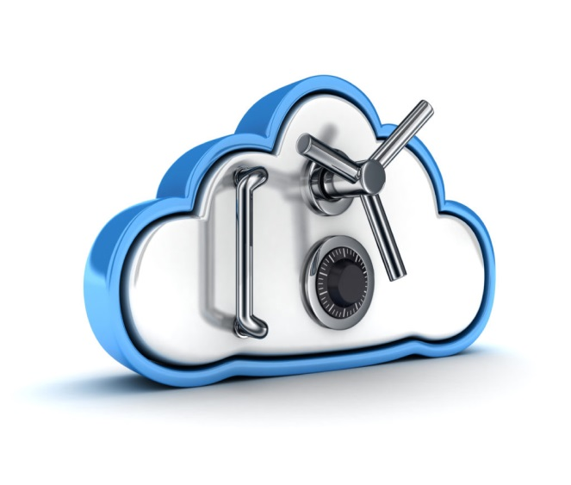**PREVENTING THE SECURITY GAP IN THE CLOUD**

It’s no secret that people and businesses are moving to the cloud at a rapid rate. The latest figures show that in 2018 most organizations will have around 40 per cent of their apps and platforms on the cloud. That number is expected to grow. But it will hardly grow up to 100 per cent.

One of the main reasons for this is that companies are frightened to have a high profile cloud-related cyber-attack.

It wasn’t that long ago that UBER got hacked and the crooks walked away with personal data from 57 million users that included 600,000 U.S. automobile licenses. What made this attack worse is the fact that UBER kept it silent for more than a year and decided to pay the ransom. The cyber crooks were able to grab log-in credentials from a GitHub repository used by UBER’s development team that was left unprotected.

Not just businesses, but individuals are equally at risk. Last summer personal information from 198 million American voter records was left exposed. What makes this situation scary is it wasn’t a hack at all. The database was publicly accessible on an Amazon S3 server. The database had been misconfigured allowing it to be available to anyone searching online. This brings to light the need for a simple, cloud-friendly solution that can protect data and people.

According to Amit Bareket, the co-founder and CEO of Perimeter 81 (an Israel-based developer of cloud-enabled VPNs with 24/7 protection that provides automatic WIFI security on the go) it could have been prevented with a software-defined perimeter technology that would close cloud environments and SaaS services to everyone except authorized devices, users and locations.

At Perimeter 81, Bareket has implemented a zero-trust security model that enables users to have direct access to cloud resources and apps. This technology evaluates the user permissions and related metadata to ensure secure access remotely.

“Utilizing it, organizations can ensure that only authorized connections are being established, while keeping the cloud completely hidden from all others including the black cloud.”

https://www.techfunnel.com/information-technology/5-future-trends-in-cloud-computing/

VII. SPEAKING

**Exercise 1. This is a comparison between two types of cloud computing services. Speak about their potential customers (e.g. small business, civil service, teenagers, etc.).**

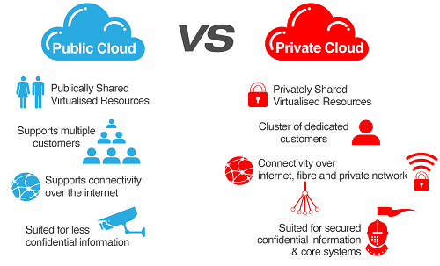

**Exercise 2. Speak about the advantages and disadvantages of these types of clouds.**

**Exercise 3. Prepare a report (a presentation) about a popular cloud service provider of your choice.**

**Exercise 4. Look at the pictures and match them with the words in the box. Prepare a short monologue trying to use as many words and phrases from the box as possible.**

|  |  |  |  |
| --- | --- | --- | --- |
| **Cloud**  **computing** | **Cloud Search** | **Data**  **Processing** | **Data Filter** |
| **Data Backup** | **Data Exchange** | **Cloud system** | **Process Automation** |
| **Cloud Technology** | **Cloud Hosting** | **Data Synchronization** | **Data Security** |

|  |  |  |  |
| --- | --- | --- | --- |
|  |  |  |  |
|  |  |  |  |
|  |  |  |  |
|  |  |  |  |
|  |  |  |  |
|  |  |  |  |

UNIT 5

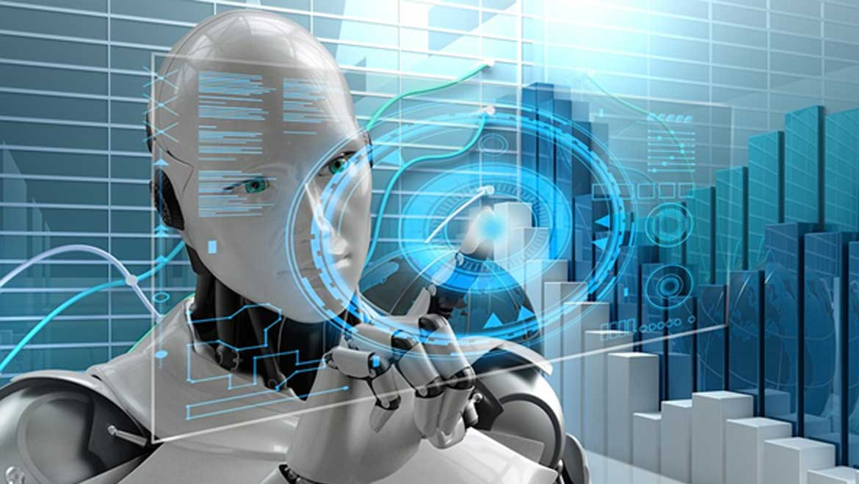

**ARTIFICIAL**

**INTELLIGENCE**

|  |
| --- |
| **Preview**  **Answer the questions:**   1. How has artificial intelligence transformed the modern world? 2. What AI gadgets are the most popular ones nowadays? 3. What are the benefits and risks of artificial intelligence? |

I. READING

****Read and translate the text

**ARTIFICIAL INTELLIGENCE**

Artificial intelligence or AI is the simulation of **human intelligence** processes by computer systems. These processes include **learning** (**retrieving information** and rules for using it), **reasoning** (using the rules to reach **approximate** or **definite conclusions**), and self-correction. **Particular** applications of AI include expert systems, speech recognition and machine vision.

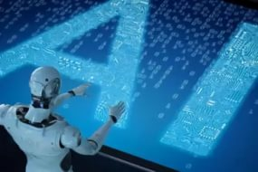AI has **gained** prominence recently due, in part, to big data, or the increase in speed, size and variety of data businesses are now collecting. AI can perform tasks such as identifying patterns in the data more efficiently than humans, enabling businesses to gain more insight out of their data. Today, this term includes everything from robotic process automation to actual robotics.

Examples of AI technology are automation, machine learning,machine vision**,**natural language processing, robotics.

**Automation** is the process of making a system or process function automatically. **Robotic process automation** (RPA)**,** for example, can be programmed to perform high-volume, repeatable tasks normally performed by humans. RPA is different from IT automation in that it can adapt to changing **circumstances**.

**Machine learning** is getting a computer to act without programming.  There are three types of machine learning algorithms:

* **supervised learning**, in which data sets are **labeled** so that patterns can be detected and used to label new data sets;
* **unsupervised learning**, in which data sets aren't labeled and are sorted according to **similarities** or differences;
* **reinforcement learning**, in which data sets aren't labeled but, after performing an action or several actions, the AI system is given feedback.

**Machine vision** makes computers see. Machine vision captures and analyzes visual information using a camera, analog-to-digital conversion and digital signal processing. It is often **compared** **to** human eyesight, but machine vision isn't **bound** **by** biology and can be programmed to see through walls, for example. It is used in a range of applications from **signature** identification to medical image analysis.

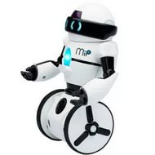**Natural language processing** (NLP) is the processing of human – and not computer – language by a computer program. One of the older and best known examples of NLP is **spam detection**, which looks at the subject line and the text of an email and decides if it's **junk**. Current **approaches** to NLP are based on machine learning. NLP tasks include text translation, sentiment analysis and **speech recognition**.

**Robotics**is a field of engineering focused on the design and manufacturing of robots. Robots are often used to **perform** tasks that are difficult for humans to perform. They are used in **assembly lines** for car production or by NASA to move large objects in space. More recently, researchers are using machine learning to build robots that can interact in **social settings**.

*[The text is adapted from URL: https://searchenterpriseai.techtarget.com/ definition/AI-Artificial-Intelligence]*

II. NOTES

|  |  |
| --- | --- |
| simulation [ˌsɪmjʊˈleɪʃn] | симуляция |
| process [ˈprəʊses] | процесс |
| efficiently [ɪˈfɪʃəntlɪ] | эффективно |
| self-correction [ˌself kəˈrekʃn] | самокоррекция |
| to collect [kəˈlekt] | собирать |
| to identify [aɪˈdentɪfaɪ] | идентифицировать |
| efficiently [ɪˈfɪʃəntli] | эффективно |
| robotic process automation [rəʊˈbɒtɪk ˈprəʊses ˌɔːtəˈmeɪʃn] | роботизированная автоматизация процессов |
| natural language processing [ˈnætʃərəl ˈlæŋɡwɪdʒ ˈprəʊsɪŋ] | обработка текстов на естественном языке |
| robotics [rəʊˈbɒtɪks] | роботехника |
| to adapt [əˈdæpt] | адаптировать |
| machine vision [məˈʃiːn ˈvɪʒn] | машинное зрение, автоматический анализ видеоинформации |
| to analyze [tə ˈænəlaɪz] | анализировать |
| visual [ˈvɪʒʊəl] | визуальный |
| analog-to-digital conversion [kənˈvɜːʃn] | преобразование из аналоговой формы в цифровую |
| eyesight [ˈaɪˌsaɪt] | зрение |
| biology [baɪˈɒlədʒi] | биология |
| identification [aɪˌdentɪfɪˈkeɪʃn] | идентификация |
| medical image analysis [ˈmedɪkəl ˈɪmɪdʒ əˈnæləsɪs] | анализ медицинских снимков |
| spam [spæm] | спам |
| subject [ˈsʌbdʒɪkt] | субъект |
| current [ˈkʌrənt] | современный |
| sentiment analysis [ˈsentɪmənt əˈnæləsɪs] | анализ тональности, эмоциональной окраски высказываний |
| focus [ˈfəʊkəs] | фокус |
| object [ˈɒbdʒekt] | объект |

III. VOCABULARY

|  |  |
| --- | --- |
| **1. intelligence** [ɪnˈtelɪdʒəns]  artificial [ˌɑːtɪˈfɪʃəl] intelligence  human [ˈhjuːmən] intelligence | интеллект  искусственный интеллект (ИИ)  человеческий интеллект |
| **2. to retrieve** [rɪˈtriːv]  to retrieve information | извлекать  извлекать информацию |
| **3. to reason** [ˈriːzn]  reasoning | рассуждать  рассуждение |
| **4. conclusion** [kənˈkluːʒn]  to reach a conclusion  approximate [əˈprɒksɪmət] conclusions  definite conclusions | вывод  приходить к выводу  приблизительные выводы  окончательные выводы |
| **5. particular** [pəˈtɪkjʊlə]  Particular applications of AI include expert systems, speech recognition and machine vision. | отдельный  Отдельные ИИ приложения включают экспертные системы, распознавание речи и машинное зрение. |
| **6. to gain** [ɡeɪn]  to gainprominence [ˈprɒmɪnəns]  to gain insight [ˈɪnsaɪt]  AI enables businesses to gain more insight out of their data. | получать  завоевать известность  вникать, получать чёткую картину происходящего  ИИ позволяет компаниям получать более чёткую картину происходящего, исходя из своих данных. |
| **7. circumstance** [ˈsɜːkəmstəns]  Robotic process automation is different from IT automation in that it can adapt to changing circumstances. | обстоятельство  Роботизированная автоматизация процессов отличается от автомати-зации в информационных технологиях тем, что она может адаптироваться к изменяющимся обстоятельствам. |
| **8. learning** [ˈlɜːnɪŋ]  machine learning  deep learning  supervised [ˈsuːpəvaɪzd] learning  unsupervised learning  reinforcement [ˌriːɪnˈfɔːsmənt] learning | обучение  машинное обучение  глубинное обучение  контролируемое обучение  неконтролируемое обучение  стимулированное обучение |
| **9. to label** [ˈleɪbl ]  to be labeled | маркировать, отмечать  быть промаркированным, отмеченным по принадлежности к ч.-л. |
| **10. similarity** [ˌsɪməˈlærəti]  similarities and differences  Inunsupervised learning data sets are not labeled and are sorted according to similarities or differences. | совпадение, сходство  сходства и различия  В неконтролируемом обучении наборы данных не отмечены и сортируются в соответствии со сходствами или различиями. |
| **11. to be compared** [kəmˈpeəd] **to smth**  Machine vision is often compared to human eyesight | быть сравниваемым с ч.-л.  Машинное зрение часто сравнивается со зрением человека |
| **12. to be bound** [baʊnd] **by smth**  Machine vision isn't bound by biology and can be programmed to see through walls. | быть связанным (ограниченным) ч.-л.  Машинное зрение не ограничено биологическими возможностями и может быть запрограммировано, чтобы видеть сквозь стены. |
| **13. signature** [ˈsɪɡnətʃə]  signature identification | подпись  идентификация по подписи |
| **14. junk** [dʒʌŋk]  Spam detection looks at the subject line and the text of an email and decides if it's junk. | ненужный хлам  Обнаружение спама рассматривает тему и текст сообщения электронной почты и решает, является ли это нежелательным. |
| **15. approach** [əˈprəʊtʃ]  current approaches | подход  современные подходы |
| **16. recognition** [ˌrekəɡˈnɪʃn]  speech recognition | распознавание  распознавание речи |
| **17. to perform** [pəˈfɔːm]  to perform high-volume, repeatable [rɪˈpiːtəbl] tasks | выполнять  выполнять крупномасштабные повторяющиеся задачи |
| **18. to capture** [ˈkæptʃə]  Machine vision captures and analyzes visual information using a camera. | захватывать  Машинное зрение захватывает и анализирует визуальную информацию с помощью камеры. |
| **19. assembly line** [əˈsembli laɪn]  Robots are used in assembly lines for car production. | конвейер  Роботы используются на конвейерах для производства автомобилей. |
| **20. social setting** [ˌsəʊʃəl ˈsetɪŋ]  Researchers use machine learning to build robots that can interact in social settings. | социальная среда  Исследователи используют машинное обучение для создания роботов, которые могут взаимодействовать в социальных условиях. |

IV. READING COMPREHENSION

**Exercise 1. Single out the operations artificial intelligence can perform.**

1. to fulfill advanced tasks in food processing industry;
2. to perform tasks more efficiently than humans;
3. to let a computer act without programming;
4. to utilize the natural flow of water;
5. to cure patients without medical treatment;
6. to compose music that can cure diseases;
7. to process human language by a computer program;
8. to cultivate grass on other planets;
9. to create robots that can interact in social settings.

**Exercise 2. Answer the questions based on the text. More than one variant can be incorrect.**

**1. What is NOT true about natural language processing (NLP)?**

1. Spam detection makes a thorough analysis of the message and then decides if it's junk or not.
2. Current approaches to NLP are based on machine learning.
3. NLP tasks include text translation, transliteration, sentiment analysis, voice encoding and speech recognition.

**2. What is NOT true about machine learning?**

1. In unsupervised learning data sets are sorted according to their similarities not differences.
2. Machine learning teaches computers to perform like humans.
3. The AI system is given feedback after performing an action in reinforcement learning.

**3. What is NOT true about robotics?**

1. Robotics is a field of engineering focused on the design and manufacturing of big and small robots.
2. Robotshelp humans to perform tasks that are difficult for them.
3. It`s impossible to build robots that can interact in social settings.

**4. What is NOT true about machine vision?**

1. Machine vision makes capture and analyze visual information.
2. Machine vision is used only in security applications.
3. Machine vision can hardly be compared to human eyesight.

**5. What is NOT directly stated in the text?**

1. Robotic process automation is different from the automation supervised by humans in that it can adapt to changing circumstances.
2. Not bound by biology, machine vision can be programmed to see through walls.
3. Artificial intelligence as the simulation of human intelligence is able to perform all tasks and operations that human intelligence can do.
4. Data sets are labeled in supervised learning so that patterns can be detected and used to label new data sets.
5. Robots are able to move large objects in space.

V. EXERCISES

**Exercise 1. Make up questions based on the text.**

1. What ………………………………………………………………………?
2. What kind of ……………………………………………………………….?
3. When ……………………………………………………………………….?
4. Who ………………………………………………………………………..?
5. Why …………………………………………………………………………?
6. Where ………………………………………………………………………?
7. How …………………………………………………………………………?
8. How many ………………………………………………….………………?

**Exercise 2. Complete the definitions of the terms from the text by filling in the blanks.**

1. __________________ is the process of making a system or process function automatically.
2. A field of engineering focused on the design and manufacturing of robots is known as a ______________________.
3. An ability to look at the subject line and the text of an email and decide if it's junk is known as ____________________.
4. The simulation of human intelligence processes by computer systems is called ___________________________.
5. A machine learning algorithm in which data sets are labeled so that patterns can be detected and used to label new data sets is called _______________________.
6. A process of retrieving information and rules for using it is called a ________________.
7. ________________ refers to the ability to adapt to changing circumstances while performing high-volume, repeatable tasks normally performed by humans.
8. ________________ refers to the process of capturing and analyzing visual information using a camera, analog-to-digital conversion and digital signal processing.

**Exercise 3. Give English equivalents to the following words and expressions:**

1. роботизированная автоматизация процессов …………………………..
2. извлекать информацию …………………………………..……….………
3. контролируемое обучение ……………………………………………..….
4. выполнять крупномасштабные повторяющиеся задачи ………………..
5. машинное зрение …………………………………………………………..
6. приблизительные выводы……………………….………………..….……
7. использовать современные подходы…….…………………………....….
8. преобразование из аналоговой формы в цифровую……………..………
9. обработка текстов на естественном языке ……………………………….
10. завоевать известность …………….…………………………………..…..
11. идентификация по подписи ……………………..……………………….
12. обнаружение спама ………………………………………………………..
13. адаптироваться к изменяющимся обстоятельствам………………………
14. человеческий интеллект …………………………………………….…….
15. анализ эмоциональной окраски высказываний ………………………….
16. распознавание речи ………………………………………………………
17. сходства и различия ………………………………………………………
18. стимулированное обучение ……………………………………………...

**Exercise 4. Compare the most** **popular types of artificial intelligence by filling in the table:**

|  |  |  |  |  |  |
| --- | --- | --- | --- | --- | --- |
|  | **automation** | **machine learning** | **machine vision** | **natural language processing** | **robotics** |
| What tasks does this type of AI perform? |  |  |  |  |  |
| What are its peculiar features? |  |  |  |  |  |
| Where can this type of AI be used? |  |  |  |  |  |

**Exercise 5. Put the given fragments in the right order to form questions.**

1. tasks / artificial / kind / perform / what / can / intelligence / of / ? .......................................………………………………………………………….
2. prominence / recently / why / gained / AI / has / ?..............……. ………………………………………………………………………………………
3. approaches / on / what / language / based / current / natural / are / processing / ? .........………………………………………………………………………..……..
4. detection / does / spam / how / work / ? ……................................................................................................................
5. data / why / learning / are / supervised / labeled / sets / in / ? ...................................……………………………………………..………………
6. automation / can / used / where / robotic / be / process / ?.......................... ………..……………………………………………………………………………..
7. to interact / will / social / be able / robots / that / settings / in future / ? ............……………………………………………………………………………
8. be compared / vision / can / human / to / machine / eyesight / ?...... ........................................................................................................................

**Exercise 6. Make your own questions based on the content of the text and ask your groupmates to answer them.**

**Exercise 7. Translate the sentences into English.**

1. Искусственный интеллект – это способ сделать компьютер, робота или программу, способную мыслить как человек.
2. Хотя первая версия системы Windows появилась в 1986, популярность у пользователей смогла завоевать только система Windows 3.0.
3. Характерной чертой машинного обучения является обучение в процессе применения решений множества сходных задач.
4. Современные программы для распознавания речи способны заменить клавиатуру.
5. Идентификацию по подписи возможно использовать повсюду. Однако этот метод не подходит для ограничения доступа в помещения или компьютерные сети.
6. Роботизированная автоматизация процессов применяется на тех предприятиях, где необходимо выполнять крупномасштабные повторяющиеся задачи.
7. В каком из видов машинного обучения наборы данных отмечаются и сортируются в соответствии со сходствами или различиями?
8. К сожалению, приблизительные выводы не всегда оказываются верными.
9. Вы хотите узнать, где и для чего используется глубинное обучение в реальной жизни?
10. ИИ приложения используются для фильтрации спама и контента низкого качества.
11. Компания разрабатывает алгоритмы машинного зрения, которые позволяют компьютерам “читать” изображения.
12. На современном производстве широкое применение получили роботизированные системы, оснащенные "машинным зрением" и различными средствами контроля движений.

**VI. SUPPLEMENTARY READING**

**1. Answer the pre-reading questions.**

1. What is a smart home?
2. Is smart home automation system secure?
3. What methods and tricks did the researchers use to hack the smart home automation system?
4. What is a common security flaw in the tested platform?

**2. Read the text and note the pronunciation of the following words:**

lock-pick malware app [ˈmælweə] – вредоносное приложение "отмычка"

proof-of-concept attacks [ˈkɒnsept] – экспериментальные, проверочные атаки

to eavesdrop [ˈiːvzˌdrɒp] - подслушивать (c помощью микрофонов)

to disguise [dɪsˈɡaɪz] - маскировать, переодевать

**HACKING INTO HOMES: 'SMART HOME' SECURITY FLAWS**

**FOUND IN POPULAR SYSTEM**

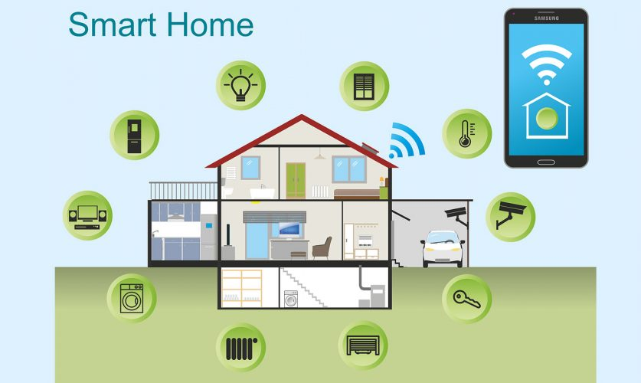University of Michigan researchers have developed a way to hack into the leading "smart home" automation system and get the PIN code to a home's front door.

The method, a "lock-pick malware app," was one of four attacks the researchers used on an experimental set-up of Samsung's SmartThings.

The researchers performed a security analysis of the SmartThings' programming framework and conducted successful proof-of-concept attacks to show the impact of the flaws they found. For example, they demonstrated a SmartApp that eavesdropped on someone setting a new PIN code for the door lock, and then sent the PIN in a text message to a potential hacker. The app was disguised as a battery-level monitor and only expressed the need for that capability in its code.

The researchers also showed that an existing, highly rated SmartApp could be remotely exploited to virtually make a spare door key by programming an additional PIN into the electronic lock. A different SmartApp was shown to be able to turn off "vacation mode," which enables the user to program the timing of lights, blinds, and other household features to help secure the home while the owner is away.

The researchers note one common security flaw. The platform grants its SmartApps too much access to devices and to the messages those devices generate.

*[Text is adapted from: URL: https://cacm.acm.org/news/201938-hacking-into-homes-smart-home-security-flaws-found-in-popular-system/fulltext]*

**VII. SPEAKING**

**1. Look at the pictures and match the gadgets and technologies with the words from the table.**

|  |  |  |  |
| --- | --- | --- | --- |
| **Automatic robotic arm** | **Exoskeleton** | **Virtual reality head set** | **Artificial intelligence** |
| **Personal hover car** | **Tracking glove** | **Hologram** | **Personal robot** |
| **Cybernetic limb** | **Augmented reality** | **Wearable tracker** | **Internet of Things** |
| **Intelligent personal assistant** | **Drone technology** | **Ambient user experience** | **Autonomous car** |

|  |  |  |  |
| --- | --- | --- | --- |
|  |  |  |  |
|  |  |  |  |
|  |  |  |  |
|  |  |  |  |
|  |  |  |  |
|  |  |  |  |
|  |  |  |  |
|  |  |  |  |

1. Prepare a short talk on one of the gadgets or technologies in the picture.
2. Tell your group mates why you want or don’t want to have a smart home automation system in your home.
3. Share your impressions with your group mates about books or movies about AI.
4. Speak about one of the current or possible future applications of AI.
5. Imagine that you have invented a time travelling machine and found yourself in the nearest future. How has the world changed? Choose one sphere of human life and tell your group mates about it.

UNIT 6

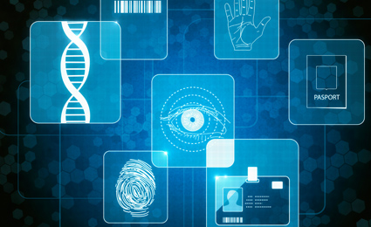

**BIOMETRIC AUTHENTICATION**

|  |
| --- |
| **Preview**  **Answer the questions:**   1. What do you know biometric authentication? 2. Where is it mostly used? 3. How has biometrics changed the issue of security in the modern world? |

**I. READING**

****Read and translate the text

**BIOMETRIC AUTHENTICATION**

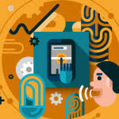Biometric **authentication** has strongly expanded in the last few years, with more and more people relying on it and even demanding for it. Biometric authentication is simply the process of **verifying** your identity using your **measurement**s or other unique characteristics of your body, then logging you in a service, an app, a device and so on. The most popular methods of biometric authentication are: fingerprint scanning, eye scanning (**retinal** scan, **iris** scan) and a facial **recognition** system.

A fingerprint scanner is a special electronic security system which is used for fingerprints scanning to **grant** user access to information or to **approve** transactions. During verification, each print is analyzed for its specific features. Then an algorithm (mathematical process) is used to turn this information into a unique numeric code. Comparing fingerprints is then simply a matter of comparing their unique codes.

There are three types of fingerprint scanners: optical, capacitive and ultrasound. An optical scanner takes a photo of the finger, identifies the print **pattern**, and then **compiles** it into an identification code. A capacitive scanner measures electrical signals sent from the finger to the scanner, maps out the contact points and air **gaps**, resulting in an absolutely unique pattern. An ultrasonic scanner scans the surface of the finger with ultrasonic waves. Similar to a capacitive one, it forms a map of the finger unique to the individual. Fingerprint scanners are widely used in smartphones, biometric door locks, biometric car starter **kits**, fingerprint-scanning **padlocks** and safes.

Eye scanning includes retinal and iris scanning. A retinal scan illuminates the complex blood **vessels** in a person’s eye using infrared light, making them more visible than the surrounding **tissue**. Iris scanners rely on high-quality photos or videos of one or both irises of a person. Some **current** and future applications of eye recognition are national **border** controls, cell phone and other wireless-device-based authentication, credit card authentication, automobile **ignition** and unlocking; **anti-theft** devices, secure financial transactions, control of access to privileged information.

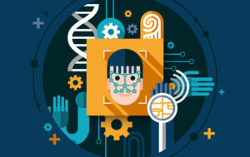Modern face recognition systems are three-dimensional techniques which use 3D sensors to capture and identify **distinctive** features on the surface of a face, such as the contour of the eye **sockets**, nose and **chin**. Today facial recognition allows to identify students at **assured** online exams (and personalized E-learning), to upscale hotel guests upon arrival, to secure universal access control, to verify one`s identity in a payment method called Selfie Pay. It can also be used to unlock phones.

Each and every biometric system is useful and the selection of a particular biometric device depends upon the application area.

*[Text is adopted from URL: heimdalsecurity.com/blog/biometric-authentication/]*

II. NOTES

|  |  |
| --- | --- |
| biometric [ˌbaɪəʊˈmetrɪk] | биометрический |
| expand [ɪkˈspænd] | расширять (ся) |
| unique [juːˈniːk] | уникальный |
| characteristic [ˌkærɪktəˈrɪstɪk] | характерный |
| capacitive [kəˈpæsətiv] | ёмкостный |
| method [ˈmeθəd] | метод |
| algorithm [ˈælɡəˌrɪðm] | алгоритм |
| numeric [njuːˌmerɪk] | цифровой |
| to compile [kəmˈpaɪl] | составлять |
| identification [aɪˌdentɪfɪˈkeɪʃn] | идентификация |
| ultrasound [ˈʌltrəˌsaʊnd] | ультразвуковой |
| absolutely [ˈæbsəluːtli] | абсолютно |
| surface [ˈsɜːfɪs] | поверхность |
| safe [seɪf] | сейф |
| to illuminate [ɪˈluːmɪneɪt] | освещать |
| secure [sɪˈkjʊə] | безопасный |
| privileged [ˈprɪvəlɪdʒd] | привилегированный |
| infrared light [ˌɪnfrəˈred laɪt] | инфракрасный свет |
| technique [tekˈniːk] | технический приём |
| contour [ˈkɒntʊə] | контур |
| personalized [ˈpɜːsənəlaɪzd] | персонифицированный |
| selection [sɪˈlekʃn] | набор |

III. VOCABULARY

|  |  |
| --- | --- |
| **1. authentication** [ɔːˌθentɪˈkeɪʃn]  biometric authentication  wireless-device-based authentication  credit card authentication | аутентификация  биометрическая аутентификация  аутентификация на основе беспроводных устройств  аутентификация кредитной карты |
| **2. to rely** [rɪˈlaɪ]  more and more people rely on it | доверять, полагаться  все больше людей полагаются на это |
| **3. to verify** [ˈverɪfaɪ]  to verify one`s identity  verification  It is enough to make a selfie to verify yourself when making a payment. | подтверждать  подтверждать личность  подтверждение  Достаточно сделать селфи для того, чтобы подтвердить личность при осуществлении платежа. |
| **4.** **to measure** [ˈmeʒə]  measurement [ˈmeʒəmənt]  Biometric authentication is simply the process of verifying your identity using your measurements or other unique characteristics of your body. | измерять  измерение, размер  Биометрическая аутентификация - это процесс проверки вашей личности с использованием ваших параметров или других уникальных характеристик вашего тела. |
| **5. retina** [ˈretɪnə]  retinal scan | сетчатка глаза  сканирование сетчатки глаза |
| **6. iris** [ˈaɪrɪs] | радужная оболочка глаза |
| **7**. **recognition** [ˌrekəɡˈnɪʃn]  facial [ˈfeɪʃəl] recognition system | распознавание  распознавание черт лица |
| **8. grant** [ɡrɑːnt]  grant user access | предоставить  предоставить доступ пользователю |
| **9. to approve** [əˈpruːv]  approve transactions [trænˈzækʃn]  A fingerprint scanner is used for fingerprint scanning to grant user access to information. | подтверждать  подтверждать сделки  Дактилоскопический сканер используется при сканировании отпечатков пальцев для того, чтобы предоставить пользователю доступ к информации. |
| **10. pattern** [ˈpætən]  print pattern | образец, рисунок  печатный образец |
| **11. to compile [kəmˈpaɪl] smth into**  **smth**  An optical scanner takes a photo of the finger, identifies the print pattern, and then compiles it into an identification code. | компилировать ч.-л. во ч.-л.  Оптический сканер делает фотографию пальца, идентифици-рует печатный рисунок, а затем компилирует его в код идентификации. |
| **12. gap** [ɡæp]  air gap | промежуток  воздушный промежуток |
| **13**. **to map** [mæp] **smth out**  to map out the contact points and air gaps  A capacitive scanner measures electrical signals sent from the finger to the scanner, maps out the contact points and air gaps, resulting in an absolutely unique pattern. | отображать ч.-л.  отображать контактные точки и воздушные промежутки  Емкостный сканер измеряет электрические сигналы, передаваемые от пальца к сканеру, отображает контактные точки и воздушные зазоры, в результате чего появляется абсолютно уникальный рисунок. |
| **14. kit** [kɪt]  biometric car starter kit | набор  биометрический автомобильный комплект стартера |
| **15. padlock** [ˈpædˌlɒk]  fingerprint-scanning padlocks | висячий замок  навесные замки со сканером отпечатков пальцев |
| **16. vessel** [ˈvesl]  blood [blʌd] vessels | сосуд  кровеносные сосуды |
| **17**. **tissue** [ˈtɪʃjuː]  surrounding [səˈraʊndɪŋ] tissue  A retinal scan illuminates the complex blood vessels in a person’s eye using infrared light, making them more visible than the surrounding tissue. | ткань  окружающая ткань  Сканирование сетчатки освещает кровеносные сосуды в глазах человека с помощью инфракрасного света, делая их более заметными, чем окружающие ткани. |
| **18.** **current** [ˈkʌrənt]  current and future applications | текущий, современный  текущие и будущие приложения |
| **19.** **border** [ˈbɔːdə]  national border controls | граница  пограничный контроль, охрана государственной границы |
| **20.** **ignition** [ɪɡˈnɪʃn]  automobile ignition and unlocking | зажигание  зажигание и разблокировка автомобиля |
| **21. theft** [θeft]  anti-theft devices | кража  противоугонные устройства |
| **22. distinctive** [dɪˈstɪŋktɪv]  to capture and identify distinctive features | отличительный  захватывать и идентифицировать отличительные черты |
| **23. socket** [ˈsɒkɪt]  eye socket | впадина, углубление  глазница |
| **24. chin** [tʃɪn] | подбородок |
| **24**. **to assure** [əˈʃʊə]  assured online exams  Today facial recognition allows to identify students at assured online exams. | заверять, подтверждать  подтвержденные онлайн-экзамены  Сегодня распознавание лица позволяет идентифицировать учащихся на подтвержденных онлайн экзаменах. |

IV. READING COMPREHENSION

**Exercise 1. Think of a title for each paragraph of the text and write down your ideas below:**

1. ……………………………………………………………………………
2. ……………………………………………………………………………
3. …………………………………………………………………….………
4. …………………………………………………………………….………
5. ……………………………………………………………………………..

**Exercise 2. Choose one or more variant(s) to answer the questions.**

**1. What is NOT true about biometric** **authentication?**

1. Biometric authentication is about the identityverificationusing unique characteristics of the body.
2. Biometric authentication is based on scanning, encoding and recognition systems.
3. The most popular methods of biometric authentication are fingerprint scanning, eye scanning, smell scanning and a facial recognition system.

**2. What is NOT true about facial** **recognition?**

1. Facial recognition can not be used to unlock phones.
2. Facial recognition is based on three-dimensional techniques which use 3D sensors.
3. Facial recognition identifies distinctive features on the surface of a face, such as the contour of the eye sockets, nose, lips and chin.

**3. What is NOT true about fingerprint scanners?**

1. The main task of fingerprint scanners is to compare the unique codes of fingerprints.
2. Ultrasonic scanners are used to scan the surface of the finger with ultrasonic waves.
3. Capacitive scanners measure electrical signals sent from the finger to the scanners mapping out the contact points and air gaps.

**4. What is NOT true about eye scanning?**

**a)** The results ofeye scanning are used in national border controls, cell phone and other wireless-device-based authentication systems.

**b)** Retina scanners rely on high-quality photos or videos of one or both irises of a person.

**c)** Retinal scan illuminates the complex bloodvessels in a person’s eye using infrared and ultraviolet light.

**5. What is NOT directly stated in the text?**

1. In fingerprint scanning special algorithms are used to turn information into unique numeric codes.
2. The facial recognition system gives a feedback about your state of health after performing the act of recognition.
3. Some applications of eye recognition will gain secret control of access to privileged information in the nearest future.

V. EXERCISES

**Exercise 1. Make up questions based on the text.**

1. What …………………………………………………………………………?
2. What kind of ……………….………………………………………………?
3. When …………………..……………………………………………………?
4. Why …………………………………………………………………………?
5. Where ………………………………………………………………………?
6. How …………………………………………………………………………? **7**. How many……………………………………………………………………?

**Exercise 2. Complete the definitions of the terms from the text by filling in the blanks.**

1. __________________ is the process of verifying your identity using your measurements or other unique characteristics of your body.
2. A scanner that takes a photo of the finger, identifies the print pattern, and then compiles it into an identification code is known as _______­­­­­_________.
3. _______________________ relies on high-quality photos or videos of one or both irises of a person.
4. The three-dimensional techniques which use 3D sensors to capture and identify distinctive features on the surface of a face arecalled ___________.
5. In __________________ scanning is an algorithm (mathematical process) which is used to turn the information about a print pattern into a unique numeric code.
6. ________________ refers to the possibility to illuminate the complex bloodvessels in a person’s eye using infrared light to make them more visible than the surrounding tissue.
7. A device for scanning the surface of the finger with ultrasonic waves is called __________________________.
8. ________________ refers tothe process of measuring electrical signals sent from the finger to the scanner and mapping out the contact points and air gaps.

**Exercise 3. Give the English equivalents.**

1. зажигание и разблокировка автомобиля ………………………………...
2. характерный ……………………………………….……..……….……….
3. противоугонные устройства ……………………………………....……..
4. биометрический автомобильный комплект стартера …………………..
5. оптический сканер …………………………………………………………
6. кровеносные сосуды ……………………….…………….………..………
7. дактилоскопический сканер …….………………………..………......….
8. навесные замки со сканером отпечатков пальцев ……………..…..…..
9. предоставлять доступ пользователю …………………………..…….….
10. идентификация по подписи ………………………..…………….…..….
11. подтвержденные онлайн-экзамены………………………………………
12. глазница …………………………………………..…………………..……
13. пограничный контроль ……………………………………………….…..
14. воздушный промежуток ………………………………………………….
15. код идентификации ……………………………………………………….
16. окружающая ткань ………………………………………………………...
17. подтверждать сделки ……………………………………………………...

**Exercise 4. Compare the most** **popular methods of biometric authentication by filling in the table:**

|  |  |  |  |
| --- | --- | --- | --- |
|  | **fingerprint scanning** | **eye scanning** | **face scanning** |
| What is scanned? |  |  |  |
| What information is obtained during the scanning process? |  |  |  |
| What form does the scanned information take? |  |  |  |
| What are the applications of biometric authentication? |  |  |  |

**Exercise 5. Put the given fragments in the right order to form questions.**

1. popular / biometric / are / methods / the / what / most / of /authentication / ? ........................................……………………………………………………
2. are / scanners / where / widely / fingerprint / used / ? …………………………
3. is / to capture / what / a face / used / and / features / identify / of / distinctive / ? .........……………………………………………………………………………
4. scan / does / retinal / how / work / ?..............................................................
5. current / what / applications / are / recognition / eye / of / future/ and / ? ................................……………………………………………..……………
6. patterns / code / are / compiled / why / into / identification / print / an / ? .........................………..……………………………………………………….
7. scan / how / a / does / retinal / work / ?.............................................................
8. fingerprint / compared / compared / is / scanning/ ?........................................

**Exercise 6. Make your own questions based on the content of the text and ask your groupmate to answer them.**

**Exercise 7. Translate the sentences into English.**

1. Департамент транспортной безопасности объявил о планах использования технологии распознавания лиц во всех аэропортах и терминалах.
2. Многие современные автомобили уже оснащены биометрическим комплектом стартера.
3. Основными стандартами аутентификации в беспроводных сетях являются стандарты IEEЕ 802.11, WPA, WPA2 и 802.1x.
4. Все последние модели смартфонов оснащены дактилоскопическими сканерами, которые используют не только для повышения безопасности устройства, но и для выполнения ряда других функций.
5. Вы знаете, как проходит процедура подтверждения личности при осуществлении платежа?
6. Некоторые навесные замки со сканером отпечатков пальцев можно открыть дистанционно при помощи специального приложения на смартфоне.
7. При оформлении биометрического паспорта необходимо не только сдать отпечатки пальцев, но и пройти процедуру сканирования сетчатки глаз.
8. Могу ли я предоставить отдельный доступ другим пользователям на Яндекс диске?
9. Механические противоугонные средства стоят дешевле, чем электронные сигнализации, они проще в установке и использовании.
10. Емкостные сканеры являются сегодня наиболее распространенными полупроводниковыми устройствами для получения изображения отпечатка пальца.

**VI. SUPPLEMENTARY READING**

**1. Answer the pre-reading questions.**

1. What self-service will soon appear in the airports?
2. What procedures will it encompass?
3. What security operations will it support?
4. How will it reduce airport stress and strain?

**Read the text and express your opinion about “Fly to Gate” service. Identify its advantages and disadvantages**.

**FLY TO GATE**

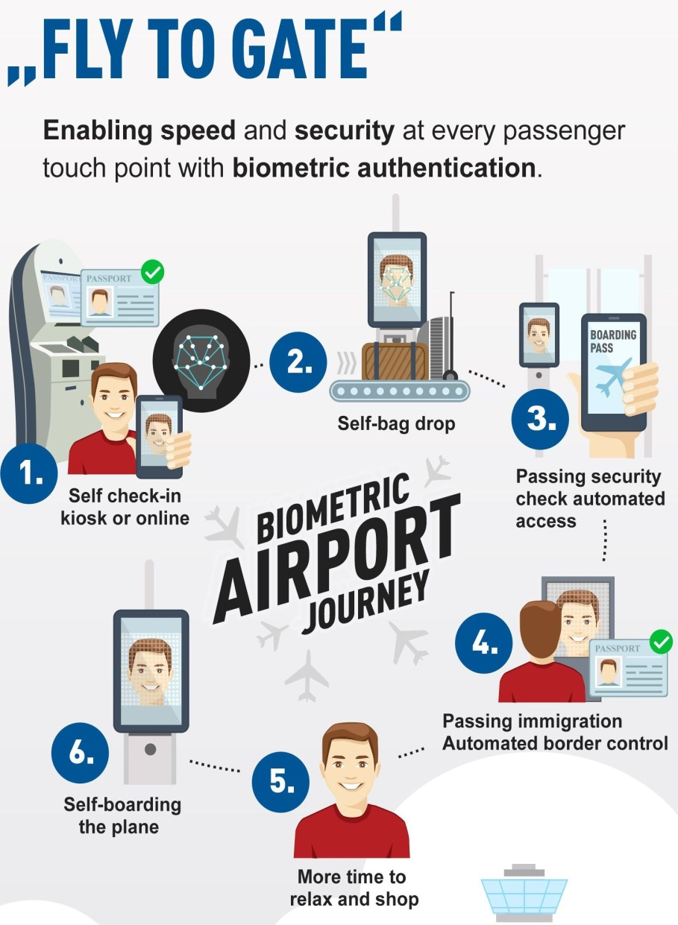Gemalto, a provider of digital security, and IER, a provider of terminals and air and rail travel networks have teamed to create "Fly to Gate," an end-to-end, self-service airport experience for travelers, according to a press release.

A Fly to Gate departure solution encompasses mobile or fully automated check-in stations, bag drop points, border control, security and boarding gates.

Fly to Gate supports multimodal biometric checking, including facial recognition, document verification and integration with immigration systems. Multimodal biometric checking corresponds to the standards of security and operational efficiency for airports and airlines.

Fly to Gate offers flexibility to meet individual requirements, as well as the potential to make virtually all traveler handling processes automatic. By putting the passenger in control of their airport experience, the Gemalto/IER approach reduces queuing, as well as the stress and strain associated with air travel.

*[Text is adopted from URL: https://www.secureidnews.com/ news-item/self-service-airport-id-and-travel-experience-from-gemalto-ier/]*

**VII. SPEAKING**

**Exercise 1. Look at the pictures and guess the types of biometric authentication matching the icons and the words from the table.**

|  |  |  |  |
| --- | --- | --- | --- |
| **Retina recogition** | **Hand geometry** | **Signature recognition** | **Voice recognition** |
| **Getting access** | **Iris recogition** | **Privacy protection** | **Vein pattern recognition** |
| **Biometric recogition** | **DNA matching** | **Retina recogition** | **Face recognition** |
| **Fingerprint recogition** | **Authentification** | **Ear shape recognition** | **Biometric data security recognition** |

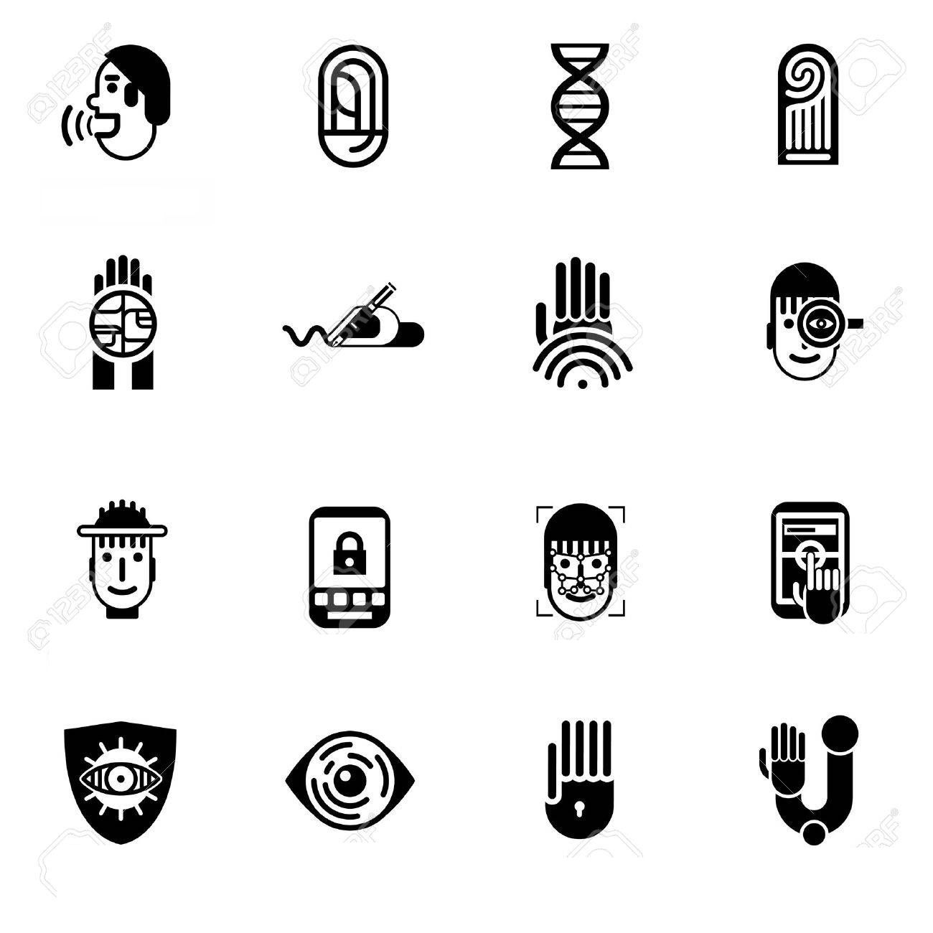

Work in pairs and speak about the places where these kinds of biometric authentication can be used.

Which types of biometric authentication are more reliable than others? Give your arguments.

Share your experience of going through biometric authentication.

**Exercise 2. Prepare a presentation about one of the methods of biometric authentication.**

UNIT 7

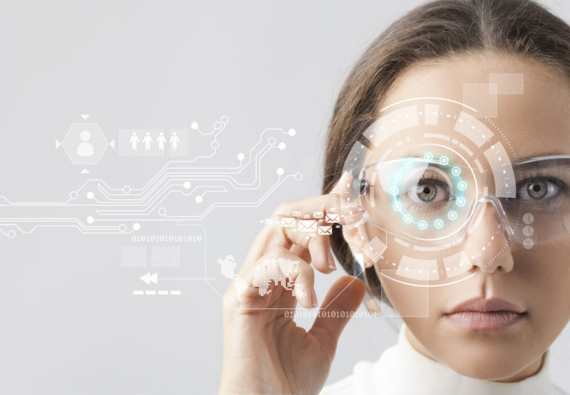

HUMAN ENHANCEMENT

|  |
| --- |
| **Preview**  **Answer the questions:**   1. How would you like to enhance your mind and body? 2. Do you know any modern technologies used to do that? 3. Can you give any examples of how modern technologies are used to make lives of people with physical disabilities easier? |

I. READING

Read and translate the text

**YOU ARE ALREADY A CYBORG**

Elon Musk says: “You are already a cyborg”. Why? Your smartphone enhances your mind, your **spectacles** enhance your vision, and your **pacemaker** (if you have one) regulates your heartbeat. Our **environment** is increasingly wired, sensor-filled, and digitally connected – and so are we! This trend will only continue.

All over the world biohackers, scientists and businessmen are **developing new marketable applications** for advanced technologies. Many of them are designed to help humans to be stronger, smarter, better-looking and **to cultivate new abilities** that seem like superpowers **by the standards of** the past.

Here is one of the new devices and technologies that could soon enhance you in body and mind: RFID chip.

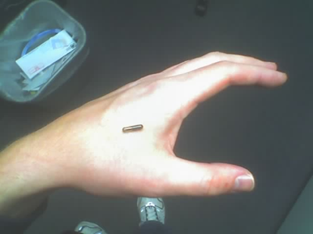Microchips are not new, but the practice of routinely implanting them in humans is. Already, biohackers are getting chipped, many of them **undergoing** the DIY **surgery** in tattoo studios. With small radio frequency identification (RFID) chips implanted in their hands or **wrists** these **citizen** cyborgs can already **eliminate** many tedious rituals from their daily lives, like carrying a **wallet** or keys.

The chip can be used **to make** **tap-and-go payments** and can be programmed to open a home or office door electronically. No more carrying keys down to the beach when going for a swim, and no more jogging with them in your pocket. One Australian biohacker, Meow-Ludo Meow Meow also thinks that chip implants could replace public transport cards.

But that’s just the basics. Chipping could soon be used on a national scale for identification and security. Hacking and **identity theft** will certainly **be a** **concern**, but **on the plus side** there will be no more **anxiety** about losing your passport when you travel!

Transhumanist candidate for Governor of California Zoltan Istvan has a chip in his wrist to open his front door. The chips can also be used in the workplace. One Swedish office complex Epicenter has already made chipping a voluntary identification option for their employees. The Belgian digital marketing firm NewFusion also began offering implants to staff in 2017.

While the fullest realization of this technology will likely be felt over several decades, it is realistic to imagine we will see these kinds of innovations improving fast and becoming more widely tested and adopted in the decade to come. You will certainly have met someone with a chip implant by 2027 and there’s a very good chance you’ll have one yourself.

II. NOTES

|  |  |
| --- | --- |
| regulate [ˈrɛɡjʊleɪt] | регулировать |
| heartbeat [ˈhɑːtbiːt] | сердцебиение |
| increasingly [ɪnˈkriːsɪŋli] | всё более |
| biohacker [ˈbaɪoʊˈhækər] | биохакер |
| advanced [ədˈvænst] [ədˈvanst] | продвинутый, развитый |
| practice [ˈpræktəs] [ˈpraktəs] | практика |
| routinely [ruˈtinlɪ] | повседневно, на регулярной основе |
| to implant [ɪmˈplænt] a chip | вставить чип, чипировать |
| implant [ˈɪmˌplænt] | имплантант |
| human [ˈhjumən] | человек |
| DIY,  'do-it-yourself' [diː aɪ waɪ] | сделанный самостоятельно |
| tattoo studio [tæˈtu ˈstjudɪˌoʊ] | тату-студия |
| ritual [ˈrɪtʃuəl] | ритуал |
| electronically [əˌlɛkˈtrɑnəklɪ] | посредством электронных устройств |
| jogging [dʒɑɡɪŋ] | пробежка |
| Australian [ɔˈstreɪlɪən] | австралийский |
| Belgian [ˈbɛldʒən] | бельгийский |
| Swedish [ˈswɪdɪʃ] | шведский |
| basics [ˈbeɪsɪk] | основы |
| passport [ˈpæsˌpɔrt] | паспорт |
| transhumanist [trænz ˈhjumənəst] | трансгуманист |
| candidate [ˈkændɪdət][ˈkandɪdeɪt] | кандидат |
| governor [ˈɡəvənər] | губернатор |
| voluntary [ˈvɑlənˌtɛrɪ] | добровольный |
| firm [fərm] | фирма |

III. VOCABULARY

|  |  |
| --- | --- |
| 1. **spectacles** [ˈspektəkəlz] | очки |
| 1. **pacemaker** [ˈpeɪsˌmeɪkər]   Your smartphone enhances your mind, your spectacles enhance your vision, and your pacemaker regulates your heartbeat. | кардиостимулятор  Ваш смартфон делает вас умнее, очки улучшают ваше зрение, а кардиостимулятор регулирует сердцебиение. |
| 1. **environment** [ɪnˈvaɪrənmənt] | окружающая среда, окружение |
| 1. **to develop new marketable applications**   Biohackers, scientists and businessmen are developing new and marketable applications for advanced technologies. | разработать новые востребованные на рынке приложения  Биохакеры, ученые и бизнесмены разрабатывают новые востребован-ные на рынке применения новейшим технологиям. |
| 1. **to cultivate** [ˈkəltəˌveɪt] **new abilities** | развивать новые способности |
| 1. **by the standards** [ˈstændərdz] **of smth**   These new abilities seem like superpowers by the standards of the past. | по стандартам чего-л.  Эти новые способности кажутся суперспособностями по меркам прошлого. |
| 1. **to undergo** [ˌəndərˈɡoʊ]   **to undergo а surgery** [ˈsərdʒərɪ] | переносить, претерпевать  перенести операцию |
| 1. **wrist** [rɪst] | запястье |
| 1. **citizen** [ˈsɪtɪzən]   citizen cyborg [ˈsʌɪbɔːɡ] | гражданин  гражданин-киборг |
| 1. **to eliminate** [ɪˈlɪmɪneɪt] **smth.**   to eliminate a tedious [ˈtiːdɪəs] ritual from one’s daily life | устранять что-л., избавиться от чего-л.  избавиться от утомительного ритуала в своей жизни |
| 1. **wallet [ˈwɒlɪt]** | бумажник |
| 1. **to make tap-and-go payments**   [tap ənˈɡoʊ ˈpeɪmənts] | производить «оплату в одно касание» |
| 1. **to be used on a national scale**   [skeɪl]  Chipping could soon be used on a national scale for identification and security. | использоваться в общенациональном масштабе  Чипирование, возможно, скоро будет использоваться в общенацио-нальном масштабе в целях идентификации личности и безопасности. |
| 1. **identity theft** [θɛft] | кража идентификационных данных |
| 1. **to be a concern** [kənˈsəːn]   Hacking and identity theft will certainly be a concern. | вызывать озабоченность  Взлом и кража идентификационных данных, безусловно, будут вызывать озабоченность. |
| 1. **on the plus side** [plʌs saɪd] | положительный момент в том, что... |
| 1. **anxiety** [aŋˈzʌɪətɪ] **about smth.**   But on the plus side there will be no more anxiety about losing your passport when you travel! | тревога по поводу чего-л.  Положительным моментом будет отсутствие тревоги по поводу утери паспорта во время путешествий! |
| 1. **to be adopted** [əˈdɒptɪd] | применяться, осваиваться |

IV. COMPREHENSION CHECK

**Exercise 1. Answer the questions.**

**1. Why can we be called cyborgs?**

1. Our environment is increasingly wired.
2. We use various electronic devices to enhance our body and mind.
3. The trend to use electronics will continue.
4. We all have wires inside.

**2. What is NOT true about the RFID chip implants?**

1. Chipping has been made a voluntary identification option for some employees.
2. Chipping is already used on a national scale for identification and security in some countries.
3. There is a chance you will have met someone with a chip implant by 2027.
4. People with the RFID chip will have no anxiety about hacking and identitytheft.

**3. What is NOT directly stated in the text?**

1. RFID chips can help people become better-looking.
2. If your RFID chip is programmed to open your door electronically, there is no more need for jogging with your keys.
3. RFID implants have replaced public transport cards.
4. The chip can be programmed to open a car electronically.
5. Chipping is already used in the workplace by some companies.
6. Innovations like the RFID chip will be widely tested and adopted in the next decade.

**Exercise 2. Answer the questions according to the text:**

1. What word is used in the text to speak of our present day environment?
2. Who is most interested in developing marketable applications for advanced technologies?
3. How can new technologies help humans?
4. What is an RFID chip?
5. What parts of the human body are RFID chips most often implanted in?
6. Where do biohackers often undergo the DIY surgery?
7. How do PFID chips make life easier for biohackers?
8. Why will people with the RFID chip have no anxiety about losing a passport?
9. What examples of the use of RFID chips in the workplace are given in the text?
10. When will we probably meet someone with an RFID implant?

**Exercise 3. Number the titles for the paragraphs, putting them in the correct order:**

__ Predictions for use of chips in the future

__ Advantages and disadvantages of the use of chipping on a national scale.

__ Examples of the use of chipping for identification.

__ The spread of chipping among biohackers

__ The motivation behind the development of many advanced technologies

__ Convenient ways to use RFID chip

__ The reason we can be called cybermen.

**V. EXERCISES**

**Exercise 1. Give English equivalents to the following words and expressions:**

1. востребованные на рынке приложения____________________________
2. по стандартам прошлого ________________________________________
3. избавиться от утомительного ритуала_____________________________
4. производить «оплату в одно касание»_____________________________
5. развивать новые способности ___________________________________
6. использоваться в общенациональном масштабе ____________________
7. беспокойство по поводу потери паспорта _________________________
8. перенести операцию ___________________________________________
9. окружающая среда ____________________________________________
10. с другой стороны _____________________________________________
11. кража идентификационных данных ______________________________
12. применяться, осваиваться ______________________________________

**Exercise 2. Match each vocabulary word with its definition. Note that there are more definitions than words.**

|  |  |
| --- | --- |
| _____ wrist | **1**: regularly |
| _____wallet | **2:** fear and stress |
| _____pacemaker | **3:** a way to use something |
| _____application | **4:** walk under ground |
| _____rituals | **5:** surrounding conditions |
| _____cultivate | **6:** tiring and boring |
| _____adopt | **7:** remove something completely |
| _____citizen | **8:** a device to help the heart beat in the right way |
| _____undergo | **9:** help grow |
| _____implant | **10:** part of the body between the hand and the arm |
| _____eliminate | **11:** accept |
| _____anxiety | **12:** have, experience |
| _____tedious | **13:** insert |
| _____environment | **14:** a person who lawfully lives in a country |
| _____routinely | **15:** a small case for keeping banknotes and credit cards. |
|  | **16:** series of actions always done the same way for religious or other reasons |
|  | **17:** a person with an chip in his body |

**Exercise 3. Find the listed words in a wordsearch puzzle. The words are placed vertically, horisontally and diagonally.**

**Q W B Z Y H Z X I A S J**

**C H M C I T I Z E N S N**

**O L W K Z O E Y C E P M**

**N J P A H U Y I T K E B**

**C G S W U E L A X R C I**

**E N V I R O N M E N T U**

**R E T A V I T L U C A N**

**N M E Z M Y S I I X C D**

**C O L I Y O V T L C L E**

**S Q L P A C E M A K E R**

**C E A Z Y R E G R U S G**

**X Y W A I X C J W P G O**

ANXIETY

CITIZEN

CONCERN

CULTIVATE

ELIMINATE

ENVIRONMENT

PACEMAKER

SPECTACLES

SURGERY

UNDERGO

WALLET

WRIST

**Exercise 3. Translate the sentences into English.**

1. Эта технология была освоена совсем недавно.
2. Этот проект будет принят в общенациональном масштабе.
3. Если у тебя нет наличных в бумажнике, это не должно быть предметом беспокойства: ты можешь производить оплату в одно касание банковской картой.
4. Что может устранить обеспокоенность пользователей соцсетей по поводу защиты персональных данных?
5. Положительный момент в том, что кража идентификационных данных будет невозможна.
6. По стандартам прошлого, искусственный интеллект – это невероятно продвинутая технология.
7. Чтобы развить новые способности, некоторые биохакеры проходят через несколько операций.

VI. SUPPLEMENTARY READING

1. **Answer the following pre-reading questions:**

* **What sci-fi books or films do you know which are about enhancing the human mind or body? What improvements are suggested? Do you think such enhancements are possible to achieve in the near future?**
* **What weaknesses of the human body would you eliminate if you could?**

1. **Read the text. Note the pronunciation of the following words:**

exoskeleton [ˌeksoʊˈskelətən] – экзоскелет

tissue[ˈtɪʃuː] [ˈtɪsjuː]– ткань

**endurance** [ɪnˈdʒʊərəns]– выносливость

**spinal cord injury** [ˈspaɪnəl kɔːd ˈɪndʒəri] – травма позвоночника

recreation [ˌrekriˈeɪʃən] – отдых, развлечение

**EXOSKELETONS**

The Terminator was “a cybernetic organism: living tissue over a metal endoskele-ton.” But that was in 1984 and the concept was fictional. Jump ahead to the 2020s and you could be a different kind of cyborg – one that wears a metal exoskeleton over your biological body.

Why would you? If you’re in the military, particularly in combat, an exoskeleton can dramatically enhance your strength and endurance and allow you to carry more supplies when moving on foot.

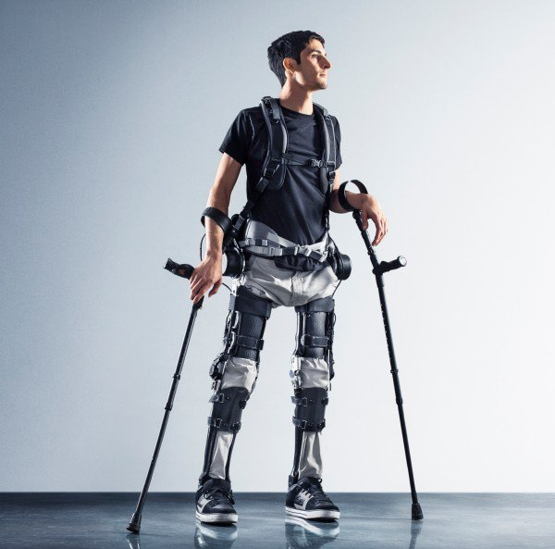If you’re just a regular human then carrying supplies is probably not a big concern. But back pain likely is. Sure, an exoskeleton may not help an office worker much, but it could be a big help to factory workers and manual laborers. In the near future exoskeletons could help laborers to use the correct muscles when lifting and allow them to lift more weight safely.

More profoundly, if you suffer from spinal cord injuries an exoskeleton could help you to walk again. Elderly people with mobility issues could also benefit from the technology.

The transhumanist politician Zoltan Istvan also thinks that exoskeletons could soon transform sport and other forms of recreation by helping us to reach new physical peaks and compete at a different level.

*Paralyzed from the waist down, Steven Sanchez walks with the aid of an exoskeleton. Image credit: MIT Technology Review/SuitX*

*[Text is adapted from https://bigthink.com/10-human-body-modifications-you-can-expect-in-the-next-decade]*

**1. What ideas does this text NOT discuss? (Choose one or more answers)**

1. Exosetelons can give people back pain.
2. Exosetelons will allow you to walk longer without getting tired.
3. Exoskeletons can help teach little children how to walk.
4. Sports competitions will be different if sportsmen use exoskeletons.

**2. What is TRUE about exoskeletons? (Choose one or more answers)**

1. Exoskeletons consist of living tissue.
2. After wearing an exoskeleton for a while a person becomes stronger.
3. Office workers do not need exoskeletons as much as factory workers do.
4. Exoskeletons could help some old people to move around more.

**3. What is the best title for paragraph 3?**

1. Back pain in different working environments.
2. The benefits of exoskeletons for manual workers.
3. How regular office workers can get help carrying supplies.
4. A big concern about safety.

**4. What 5 categories of people mentioned in the text can benefit from exoskeletons?** __________________, _______________, ________________, ___________________, _____________________.

**5. What other categories of people can exoskeletons benefit? In what way would exoskeletons be beneficial for them?**

VII. SPEAKING

**Exercise 1. Among other things, transhumanists want humans to live longer lives. Do you think everyone will want to use new technologies to be able to live for 150 years? How will our lives change if this becomes possible?**

**Exercise 2. What questions would you ask a biohacker if you had a chance to interview one? Prepare a list of questions, then act out an interview with one of your classmates playing the role of a biohacker.**

**Exercise 3. Prepare a presentation on one of human body modifications expected in the next decade:**

* Real-time Language Translation
* Augmented Vision
* Smart Contact Lenses
* 3D Printed Body Parts
* Brain-computer Interfaces
* Dating In Virtual Reality

**Exercise 4. Do you think the technologies listed in Exercise 3 can be hacked? Describe some of the possible scenarios showing how an unauthorized access to technologies enhancing human body and mind can be dangerous.**

**Exercise 5. Watch a video “Hacking Implanted Medical Devices”. Note the meaning of the following words:**

defibrillator [dɛfɪbrɪˈlatər] – дефибрилятор

cardiac arrest – остановка сердца

hearing impaired – человек с полной или частичной потерей слуха

hearing aid – слуховой аппарат

cochlear [ˈkɒklɪə] implant – кохлеарный имплантант

skull – череп

auditory nerve – слуховой нерв

exploits – вредоносный код, эксплуатирующий уязвимость ПО

grand mal seizures – приступ эпилепсии

**After watching the video, answer the following questions:**

1. **Which type of devices is not menioned by the speaker?**
2. Wearable
3. Embeddable
4. Invincible
5. Implantable
6. **How does each of these devices function?**
7. cochlear implant;
8. diabetic insuline pumps;
9. Internet-enabled defibrilator.
10. **What possible scenarios of hackers’ attack does the speaker give for each of the following devices:**
11. cochlear implant;
12. diabetic insuline pumps;
13. Internet-enabled defibrilator.
14. **What is the speaker’s explanation of the reason for possible hacking attacks?**
15. **What other reasons for hacking various implanted devices can you think of?**
16. **Do you think these body implants should be used even though they are potenially dangerous? Explain.**

Список использованных источников:

Image on the cover: https://www.cpomagazine.com/2018/02/19/artificial-intelligence-privacy-and-legal-issues/

Unit 1 Big Data

1. Image 1 - Режим доступа: http://newtechnologytodayus24h.com/big-data-machine-learning/
2. [Judith Hurwitz,](http://www.dummies.com/?s=&a=judith-hurwitz)[Alan Nugent,](http://www.dummies.com/?s=&a=alan-nugent)[Fern Halper,](http://www.dummies.com/?s=&a=fern-halper)[Marcia Kaufman](http://www.dummies.com/?s=&a=marcia-kaufman). Big Data for Dummies Cheat Sheet. – Режим доступа: http://www.dummies.com/programming/big-data/big-data-for-dummies-cheat-sheet/
3. What Is Big Data and How Does It Work? [Видеоресурс] – Режим доступа: https://www.you-tube.com/ watch?v= TzxmjbL-i4Y

Unit 2 Data Mining

1. Image 1 – Режим доступа: https://www.johod3.com/products-and-services/data-mining/
2. Data Mining: What It Is And Why It Matters – Режим доступа: <https://www.sas.com/en_us/insights/analytics/data-mining.html>
3. Image 2 – Режим доступа: <https://www.sas.com/en_us/insights/analytics/data-mining.html>
4. People with Depression Use Language Differently – Here’s How to Spot It – Режим доступа: theconversation.com/people-with-depression-use-language-differently-heres-how-to-spot-it-90877

Unit 3 Data Security

1. Image 1 - Режим доступа: https://www.thirdsector.co.uk/cyber-data-security-prepared-charity/article/1417419
2. What is Data Security? / Microfocus. – Режим доступа: https://software.microfocus.com/en-us/what-is/data-security
3. Tokenization vs. Encryption / McAfee. – Режим доступа: https://www.skyhighnetworks.com/cloud-security-university/tokenization-vs-encryption/
4. 10 Best Practices for Encryption Key Management and Data Security / Technopedia. – Режим доступа: https://www.techopedia.com/2/30767/security/ 10-best-practices-for-encryption-key-management-and-data-security

Unit 4 Cloud Technology

1. Image 1 – Режим доступа: <http://rtmbtechnology.com/cloud-based-technology>
2. Image 2 – Режим доступа: <http://www.vensi.com/cloud-computing-technology>
3. Image 3 – Режим доступа: <https://www.amyma.lu/hybrid-cloud.html>
4. Cloud Technology [Electronic text] – Режим доступа: https://www.zdnet.com/ article/what-is-cloud-computing-everything-you-need-to-know-from-public-and-private-cloud-to-software-as-a/
5. Image 4 – Режим доступа: https://www.axoncs.com/is-the-cloud-secure/
6. Image 5 – Режим доступа: <https://www.information-age.com/cloud-security-dilemma-secure-notsecure-123468571/>
7. Suppl text – Режим доступа: https://www.techfunnel.com/information-technology/5-future-trends-in-cloud-computing/
8. Image 6 – Режим доступа:https://www.vectorstock.com/royalty-free-vector/web-hosting-glyph-icon-designs-1-vector-18885091

Unit 5 Artificial Intelligence

1. Image 1 – Режим доступа:<https://fi.co/insight/insights-from-the-leaders-building-scaling-and-funding-artificial-intelligence-and-robotics-startups>
2. Image 2 – Режим доступа: ttps://www.google.com/search?q =artificial+intelligence&rlz=1C1AOHY_ruRU719RU719&source=lnms&tbm=isch&sa=X&ved=0ahUKEwjh8pfHnPHfAhWC2SwKHYwTDmoQ_AUIDigB&biw=1024&bih=509#imgrc=jmE9fOuAPvNnbM:
3. Artificial-Intelligence [Electronic text] – Режим доступа: https://searchenterpriseai.techtarget.com/ definition/AI-Artificial-Intelligence
4. Image 3 – Режим доступа: <https://www.letsbuyrobots.com/en/robot-mip>
5. Image 4 – Режим доступа: <https://techspective.net/2017/09/01/top-tips-creating-streamlined-smart-home/>
6. Image 5 – Режим доступа: https://www.istockphoto.com/ru/% D0%B2%D0%B5%D0%BA%D1%82%D0%BE%D1%80%D0%BD%D0%B0%D1%8F/artificial-intelligence-glyph-vector-icons-set-gm1015598654-273305007
7. Hacking into Homes: 'Smart Home' Security Flaws Found in Popular System – Режим доступа: https://cacm.acm.org/news/201938-hacking-into-homes-smart-home-security-flaws-found-in-popular-system/fulltext

Unit 6 Biometric Identification

1. Image 1 – Режим доступа: https://findbiometrics.com/study-finds-biometric-authentication-less-popular-work-508302/
2. Image 2,3 – Режим доступа: https://www.123rf.com/photo_38304119_ stock-vector-biometric-authentication-design-concept-set-with-privacy-protection-data-security-and-recognition-fl.html
3. Biometric Authentication. – Режим доступа: heimdalsecurity.com/blog/biometric-authentication/
4. Supplementary text – Режим доступа: https://www.secureidnews.com/ news-item/self-service-airport-id-and-travel-experience-from-gemalto-ier/
5. Image 4 – Режим доступа: <https://www.secureidnews.com/news-item/self-service-airport-id-and-travel-experience-from-gemalto-ier/>
6. Image 5 – Режим доступа:https://ru.depositphotos.com/69395169/stock-illustration-biometric-authentication-icons-black.html

Unit 7 Human Enhancement

1. Image 1 – Режим доступа: https://medium.com/@jasonfoster_19698/human-augmentation-its-potential-to-revolutionize-the-human-race-ef93d1642af7
2. You Are Already a Cyborg, Image 2, Exoskeletons resource: Bohan, Elise. 10 Human Body Modifications You Can Expect in the next Decade // BIGTHINK. – 12 March, 2017. – Режим доступа: https://bigthink.com/10-human-body-modifications-you-can-expect-in-the-next-decade
3. Image 3 – Режим доступа: https://www.freepressjournal.in/entertainment/india-promotion-of-terminator-genisys-gets-unique-twist/611583